

## SENARAI SEMAK PERMOHONAN SEMAKAN ETIKA FSKM

PaNDUAn kepada Pemohon:

|  |  |  |
| --- | --- | --- |
| **Bil.** | **Tindakan/Dokumen yang Diperlukan** | **Tandakan (√)** |
| 1. | Pastikan permohonan lengkap dengan menyertakan dokumen sokongan di bawah:   1. RISK- Senarai Semak Permohonan 2. FERC/BERC 1 3. FERC/BERC 2 4. FERC/BERC 3 5. Form B 6. Proposal 7. Questionnnaire 8. Surat Kelulusan | **√** |
| 2. | Dokumen yang perlu ditandatangani oleh pemohon/ *Supervisor*/ *Internal Assessor* hendaklah dalam bentuk pdf. | **√** |
| 3. | Permohonan yang dihantar kepada *Person in Charge* (PIC) hendaklah dalam bentuk **single pdf** bagi seorang pemohon. | **√** |
| 4. | Aturan dokumen dalam **single pdf** hendaklah mengikut susunan berikut:   1. RISK - Senarai Semak Permohonan 2. FERC/BERC 1 3. FERC/BERC 2 4. FERC/BERC 3 5. Form B 6. Proposal 7. Questionnnaire 8. Surat Kelulusan | **√** |
| 5. | Dokumen **single pdf** perlu dinamakan seperti format berikut:  **KOD PROGRAM_NAMA PELAJAR/GROUP_NO PELAJAR_MR/MMR** | **√** |

|  |  |
| --- | --- |
| DikemUkakan oleh (Pemohon): | PerakUan Penerimaan (Pejabat PJI) |
|  |  |
| Tandatangan: | Tandatangan: |
| Nama: WAN PUTERA NUR SYAFIQ BIN WAN JEFERI  Tarikh: 10/3/2022 | Nama: Tarikh: |

***Nota****: Sekiranya permohonan yang dikemukakan tidak lengkap dan tidak mematuhi Template Seragam Senarai Semak Dokumen dan Senarai Semak Terperinci, pihak Pejabat Penyelidikan dan Jaringan Industri (PJI) berhak untuk menolak/membatalkan permohonan.*



**FERC/BERC 1**

**Faculty/Branch Ethics Review Committee Universiti Teknologi MARA**

**Ethics Approval Application Form for Undergraduate or Postgraduate by Coursework**

*Borang Permohonan Kelulusan Etika bagi Pelajar Sarjana Muda atau Pasca Siswazah Kerja Kursus*

This application is for the purpose of obtaining approval to conduct research involving the human subject.

Please attach a copy of the Research Proposal.

*Permohonan ini dikemukakan untuk tujuan kelulusan menjalankan penyelidikan melibatkan manusia sebagai subjek kajian.*

*Sila lampirkan salinan kertas Cadangan Penyelidikan.*

**Part A: Details of Researcher**

*Bahagian A: Maklumat Penyelidik*

Title of Research Project:

*Tajuk Penyelidikan:*

Virtual Buddy Application: Chat Management System for

UiTM Staff Using Progressive Web Application

Name of Student: Wan Putera Nur Syafiq Bin Wan Jeferi

*Nama Pelajar:*

Name of Supervisor: Assoc. Prof. Dr. Suriyani Binti Ariffin

*Nama Penyelia*:

Faculty/Academy/Branch:

*Fakulti/Akademi/Cawangan:*

Faculty of Computer & Mathematical Sciences

Contact No/ Email:

*No.Telefon/ Emel:*

+601137982616 / [2020836988@student.uitm.edu.my](mailto:2020836988@student.uitm.edu.my)

* Undergraduate / *Sarjana Muda*



* Postgraduate by Coursework/ *Pasca Siswazah Kerja Kursus*

|  |  |
| --- | --- |
| Does the research require an external Research Ethics Committee approval? (e.g. MREC)  *Adakah penyelidikan ini memerlukan kelulusan Jawatankuasa Etika Penyelidikan Luaran?*  *(contoh MREC)* | |
| * Yes / *Ya* * No / *Tidak* | External Committee Name: |

Research funding: Yes/ No

*Dana Penyelidikan: Ada/ Tiada*

If Yes, please complete section C.

*Jika Ada, sila lengkapkan bahagian C.*

**Part B: Research Details**

*Bahagian B: Maklumat Penyelidikan*

|  |  |
| --- | --- |
| **Part B1**  ***Bahagian B1*** | |
| * Interviews   *Temubual*   * Focus groups   *Kumpulan terfokus*   * Questionnaires   *Soal selidik*   * Action research   *Kajian tindakan*   * Observation   *Pemerhatian* | * Case study   *Kajian kes*   * Intervention study   *Kajian intervensi*   * Personal records   *Rekod peribadi*   * Secondary data analysis   *Analisis data sekunder*   * Others (provide details):   *Lain-lain (nyatakan):* |

|  |  |
| --- | --- |
| **Part B2**  *Bahagian B2* | |
| **1.** | **Background:**  *Latar belakang:*  A brief explanation of the problem to be studied and literature review (citations) to support. *Keterangan ringkas tentang masalah yang dikaji dan soroton kajian (sitasi) untuk menyokong keterangan tentang masalah yang dikaji.*  With the growth and advancement of new technology, particularly in chat applications, it is now possible to link individuals all over the world. It is one of the most essential tools for uniting society and delivering messages in a matter of seconds. However, with such advantages and benefits come drawbacks such as cyberbullying and the spreading fake news. As a result, having a chat management system in addition to the chat application is critical. So, a system called Virtual Buddy: Chat Management System using Progressive Web Application will be developed.  The chat management system is a system that allows clients, also known as users, to connect with one another while having their chats monitored on the server. The suspicious keywords are saved in a database, and only the administrator has access to it to add new keywords and change data if necessary. The server examines plain text and notifies the administrator if any suspicious phrases are discovered. When the admin receives the notification, he or she will block the user so that they can no longer chat (ladychampionz, 2020). |

|  |  |
| --- | --- |
|  | **Problem statement** (Less than 100 words)**:**  *Penyataan masalah (Kurang dari 100 patah perkataan):*  One of the study's key concerns is the issue of cyberbullying. Cyberbullying perpetrators assault the victim of cyberbullying through internet communication means such as chat rooms. Cyberbullying has a significant impact on the physical and emotional health of those who are subjected to it.  Another issue raised by this research is the propagation of fake news. University students are readily misleading and led to Fake News, which they easily disseminate.  **References:**  *Rujukan:*  Only include references cited in this document. Do not paste all your references from your main proposal  *Hanya sertakan rujukan yang dipetik dalam dokumen ini. Jangan tampalkan semua rujukan dari kertas cadangan utama anda*  ladychampionz (2020).*” Active Chat Monitoring and Suspicious Chat Detection over Internet”.* https://projectchampionz.com.ng/2020/04/18/active-chat- monitoring-and-suspicious-chat-detection-over-internet/ |
| **2.** | **Research objectives (enumerate):**  *Objektif penyelidikan (senaraikan):*  Number your objectives  *Nomborkan objektif anda*   1. To identify the suitable features that can be included in the proposed web base application regarding chat management system. 2. To design and develop web base application to assist the UiTM staff in managing student chat activities. 3. To evaluate the functionality of the developed web base application. |
| **3.** | **Expected benefits** (Less than 100 words)**:**  *Faedah yang dijangka (Kurang dari 100 patah perkataan):*  This system will make it easier for UiTM staff to monitor student chat activities in the virtual buddy application. This can avoid abuse use of Virtual Buddy App such as cyberbullying and spread fake news. In addition, this system will also make it easier for staff to remove access to students who cause a problem when using the virtual buddy application. This system can also make it easier for staff to monitor chat rooms created by students. This can prevent students from creating chat rooms that do not bring benefits and chat rooms that have bad elements. |

|  |  |
| --- | --- |
| **4.** | **Date of research commencement-end:**  *Tarikh penyelidikan bermula-berakhir:*  March 2022 – July 2022 |
| **5.** | **Expected date of initial data collection:**  *Jangkaan tarikh pengumpulan data bermula:*  At least TWO (2) months before submission of this form  Sekurang-kurangnya DUA (2) bulan sebelum penghantaran borang ini  April 2022 |
| **6.** | **Location of research:**  *Lokasi penyelidikan dijalankan:*  Universiti Teknologi MARA cawangan Shah Alam |

**Research design dan methodology:**

*Rekabentuk penyelidikan dan metodologi:*

The waterfall model was employed as the project's fundamental basis. This paradigm is appropriate for the creation of web application and mobile applications.

**7.**

|  |  |  |
| --- | --- | --- |
| PHASE | ACTIVITIES | OUTCOME |
| Requirement Analysis | * Define project title * Define problem statement * Doing research through internet journal and publications to support problem statement * Define objective, scope, and requirements * Literature review research | * Problem statement * Objective * Scope and significant * Comparison of existed application |
| System Design | * Design System Flowchart * Design System Entity Relation Diagram * Design Use Case Diagram * Design Graphical   User Interface (GUI) | * System Flowchart * System Entity Relation Diagram * Use Case Diagram * User Interface Design |
| Implementation | * Develop the system using Visual Studio, XAMPP and   Google Chrome | * Virtual Buddy Application: Chat Management System |
| System Testing | * Test Case Generation | * Test Result |
| System Deployment | * Deployment of the system | * The end user can use the system |
| System Maintenance | * Fix faults or bug | * The system will   have a new update and improvement |

|  |  |
| --- | --- |
| **8.** | **Inclusion and exclusion criteria:**  *Kriteria kemasukan dan pengecualian:*  **Inclusion criteria:**  *Kriteria kemasukan:*   * Characteristics of your participants (*Ciri-ciri peserta kajian anda*)   1. Student of UiTM   2. Age above 18   **Exclusion criteria:**  *Kriteria pengecualian:*   * Characteristics that disqualify prospective participants from joining this study (*Ciri- ciri yang membatalkan calon peserta untuk mengikuti kajian ini*)   1. Not a student of UiTM   2. Age below 18 |
| **9.** | **Sample size:**  *Saiz sampel:*  State the sampling method and minimum sample size calculated.  *Nyatakan kaedah persampelan dan pengiraan saiz sampel minima.*   * Sampling method: Purposive Sampling * Sample size: 10 respondents |

|  |  |
| --- | --- |
| **10.** | **Research flowchart:**  *Carta alir penyelidikan:* |

|  |  |
| --- | --- |
| **11.** | **Statistical analysis:**  *Analisa statistik:*  Briefly describe the data analysis and statistical analysis sotfware that will be utilized.  *Huraikan secara ringkas analisis data dan perisian analisis statistik yang akan digunakan*  -NA- |

**Part C: Funding details**

*Bahagian C: Maklumat Dana*

**\* If not applicable please write ‘-NA-’ in the spaces provided.**

*Jika tiada kaitan sila tulis ‘-NA-’ di ruangan disediakan.*

|  |  |  |
| --- | --- | --- |
| **1.** | **Grant / Source:**  *Geran* / *Sumber:* | *-NA-* |
| **2.** | **Grant Registration No. (IRES):**  *No. Pendaftaran Geran:* | *-NA-* |
| **3.** | **Total allocation:**  *Jumlah peruntukan:* | *-NA-* |
| **4.** | **Duration of grant:**  *Jangkamasa peruntukan:* | *-NA-* |
| **5.** | **Others:**  *Lain-lain:* | *-NA-* |

**Part D: Agreement to conduct the research project.**

*Bahagian D: Pengesahan persetujuan menjalankan penyelidikan.*

To be completed and signed by the following members of the research group.

*Perlu dilengkapkan dan ditandatangani oleh ahli-ahli berikut dalam kumpulan penyelidikan*.

1. Student

*Pelajar*

|  |  |
| --- | --- |
| **Student ID:**  *No. Pelajar:* | 2020836988 |
| **Mobile phone:**  *Telefon bimbit:* | 011-37982616 |
| **Email:**  *Emel:* | [2020836988@student.uitm.edu.my](mailto:2020836988@student.uitm.edu.my) |

1. Supervisor

*Penyelia*

|  |  |
| --- | --- |
| **Staff ID/***No.Staf/* |  |
| **Mobile phone:** *Telefon*  *bimbit:* | 012-3266747 |
| **Email:**  *Emel:* | [suíiyani@fskm.uitm.edu.my](mailto:suíiyani@fskm.uitm.edu.my) |

1. Co-Researcher

*Penyelidik Bersama*

|  |  |  |
| --- | --- | --- |
| **Name:**  *Nama:* |  | |
| **Staff ID/Student ID:**  *No.Staf/No. Pelajar:* |  | |
| **Affiliation:**  *Jabatan:* |  | |
| **Mobile phone:** *Telefon bimbit:* |  | |
| **Email:**  *Emel:* |  | |
| **Signature:**  *Tandatangan:* |  | **Date:**  *Tarikh:* |

**Part E: Research Risk Classification**

*Bahagian E: Klasifikasi Risiko Kajian*

**PLEASE ANSWER ALL QUESTIONS BELOW.**

If your answer is ‘**Yes’** to any of the following questions, please include a brief information in the space provided.

***SILA JAWAB KESEMUA SOALAN DI BAWAH.***

*Sekiranya jawapan anda* ***‘Ya’*** *kepada mana-mana soalan di bawah, sertakan maklumat ringkas di ruang yang disediakan.*

|  |  |  |  |  |
| --- | --- | --- | --- | --- |
|  | **PARTICIPANT PROFILE** | No | Yes | Brief description (If YES) |
| 1. | Are the participants under 18 years old?  *Adakah peserta berumur di bawah 18 tahun?* | NO |  |  |
| 2. | Are the participants from a particular vulnerable group? (e.g. with mental disorder, mentally challenged, disabled, minority, disadvantaged group etc.)  *Adakah peserta daripada golongan rentan? (cth: kecelaruan mental, kelainan*  *keupayaan intelektual, berkeperluan khas, minoriti dan sebagainya.)* | NO |  |  |
| 3. | Are any of these participants/patients in terminal care?  *Adakah peserta/pesakit ini memerlukan rawatan terminal?* | NO |  |  |

|  |  |  |  |  |
| --- | --- | --- | --- | --- |
| 4. | Are any of these participants unable or are incapable of giving consent? (i.e. consent will be obtained indirectly from a legal guardian etc.)  *Adakah peserta tidak boleh atau tidak berupaya memberi izin?*  *(spt: izin akan diambil secara tidak langsung daripada penjaga sah dan sebagainya.)* | NO |  |  |
| 5. | Are the participants given any form of emolument to participate?  *Adakah peserta diberi upah untuk menyertai kajian?* | NO |  |  |
|  | **PRIVACY AND CONFIDENTIALITY** | No | Yes | Brief description (If YES) |
| 6. | Does any of the data collected have the potential to cause discomfort, embarrassment, or psychological harm to the participants?  (e.g. sexual orientation etc.)  *Adakah data yang dikumpul berpotensi untuk menyebabkan rasa tidak selesa, keaiban atau gangguan psikologi kepada peserta? (cth: orientasi seksual dan*  *sebagainya.)* | NO |  |  |
| 7. | Does your research involve measures undeclared to the participants?  (e.g. covert observations etc.)  *Adakah penyelidikan anda melibatkan langkah-langkah yang tidak dimaklumkan kepada peserta?*  *(cth: pemerhatian rahsia dan sebagainya.)* | NO |  |  |
| 8. | Will the collected data be made available to other parties not involved in the research? (e.g. government agencies)  *Adakah data yang dikumpulkan akan didedahkan kepada pihak lain yang tidak terlibat dalam penyelidikan? (cth. agensi*  *kerajaan)* | NO |  |  |
|  | **RISK OF HARM** | No | Yes | Brief description (If YES) |
| 9. | Will you be collecting biological samples e.g. body fluids?  *Adakah anda akan mengumpul sampel biologi contohnya. cecair badan?* | NO |  |  |
| 10. | Do you have access to any information that will allow the identification of individual human participants?  *Adakah anda mempunyai akses kepada apa-apa maklumat yang akan membolehkan pengenalpastian peserta secara individu?* | NO |  |  |
| 11. | Is the collection method invasive and has the potential to cause harm, pain or discomfort?  (except finger, heel, ear prick.) | NO |  |  |

|  |  |  |  |  |
| --- | --- | --- | --- | --- |
|  | *Adakah kaedah pengumpulan invasif dan berpotensi menyebabkan kemudaratan, kesakitan atau ketidakselesaan?*  *(kecuali tusukan jari, tumit, telinga.)* |  |  |  |
| 12. | Will the participants be subjected to vigorous physical tests or exercise regime?  (if ‘No’, go to Question 15.)  *Adakah peserta akan melalui ujian fizikal atau senaman berintensiti tinggi?*  *(jika 'Tidak', teruskan ke Soalan 15.)* | NO |  |  |
| 13. | Are the participants non-athletes or patients with chronic illnesses?  *Adakah peserta bukan atlet atau pesakit dengan penyakit kronik?* |  |  |  |
| 14. | Will they be subjected to maximal exercise intensity?  *Adakah mereka akan melalui senaman berintensiti maksimum?* |  |  |  |
| 15. | Is there any form of procedure/ medication involved?  *Adakah terdapat sebarang prosedur/*  *penggunaan ubat yang terlibat?* | NO |  |  |
| 16. | Is there any drug or device used with an unapproved indication?  *Adakah terdapat ubat atau peranti yang digunakan tanpa indikasi yang diluluskan?* | NO |  |  |
| 17. | Can the informed consent be obtained from anyone other than the patient/participant?  *Adakah keizinan kajian boleh diperoleh daripada sesiapa selain pesakit/peserta?* | NO |  |  |
| 18. | Is there any kind of risk to the participant if he/she chooses to withdraw?  *Adakah terdapat sebarang kemudaratan*  *kepada peserta jika dia memilih untuk menarik diri?* | NO |  |  |
| 19. | What type of biological samples will be collected?  (Please indicate amount and frequency.)  *Apakah jenis sampel biologi yang dikumpul?*  *(Sila nyatakan jumlah dan kekerapan.)* | NO |  |  |
| 20. | Will the biological samples obtained be stored for future research?  *Adakah sampel biologi yang dikumpul akan disimpan untuk penyelidikan di masa hadapan?* | NO |  |  |
| 21. | Do you propose to analyse the sample outside of the original purpose for which it has been collected?  *Adakah anda bercadang untuk menganalisis sampel bagi tujuan selain daripada tujuan asal ia diperoleh* | NO |  |  |

|  |  |  |  |  |
| --- | --- | --- | --- | --- |
| 22. | If ‘Yes’ to No. 21, will you obtain consent from participants for this purpose?  *Jika 'Ya' pada No. 20, adakah anda akan mendapatkan persetujuan daripada peserta untuk tujuan ini?* |  |  |  |
|  | **OTHER ETHICAL ISSUES** | No | Yes | Brief description (If YES) |
| 23. | Are there any other ethical issues not stated in this checklist?  *Adakah terdapat sebarang isu etika lain yang tidak dinyatakan dalam senarai semak ini?* | NO |  |  |

**Part F: Applicant Checklist**

*Bahagian F: Senarai Semak Pemohon*

|  |  |  |  |
| --- | --- | --- | --- |
| **Terms of Submission of Ethics Approval Application** | | | |
| 1. Please ensure that the named research team members have signed the application. 2. Please ensure that the application has been signed and endorsed by the Department or Postgraduate Research Committee. 3. All required documents must be submitted at least two (2) months before the data collection. 4. Any data collection instruments that require completion by respondents/participants shall be prepared in the Malay and English languages, and other language(s) understood by the participants. 5. Please ensure that you have obtained the necessary permission or paid the stipulated fee for use of survey questionnaires and/or statistical analysis software, if and when necessary. | | | |
|  | **ITEM**  *PERKARA* | **YES**  *YA* | **NO**  *TIDAK* |
| 1 | Have you presented your proposal at the Department or Postgraduate Research Committee?  *Adakah anda telah membentangkan proposal anda di Jawatankuasa Penyelidikan Jabatan atau Pascasiswazah?* | ✓ |  |
| 2 | Have you completed the F/BERC 1 form?  *Adakah anda telah melengkapkan Borang F/BERC 1?* | ✓ |  |
| 3 | Have you completed the F/BERC 2 and/or F/BERC 3 form?  *Adakah anda telah melengkapkan Borang F/BERC 2 atau dan borang F/BERC 3?* | ✓ |  |
| 4 | Has your supervisor checked your application form?  *Adakah penyelia anda telah menyemak borang permohonan anda?* | ✓ |  |
| 5 | Has the form been signed by all researchers?  *Adakah borang ditandatangani oleh semua penyelidik?* | ✓ |  |

|  |  |
| --- | --- |
| Additional comments (if any):  *Komen Tambahan (Jika Ada):* | |
|  | 10/3/2022 |
| Applicant’s Signature | Date |
|  |  |
| Supervisor’s Signature | Date |

**Part G: Verification from Department or Postgraduate Research Committee**

*Bahagian G: Pengesahan Jawatankuasa Penyelidikan Jabatan atau Pascasiswazah*

We have deliberated on the application and propose as below:

*Kami telah meneliti permohonan ini dan mencadangkan seperti di bawah:*

Minimal risk research. Recommended for approval without presentation. *Penyelidikan melibatkan risiko minima. Dicadangkan untuk mendapat kelulusan tanpa pembentangan.*

More information or presentation at BERC/FERC required.

*Perlu maklumat tambahan atau pembentangan ke BERC/FERC.*

More than minimal risk research. Recommended to be forwarded to UiTM REC. *Penyelidikan melibatkan risiko melebihi minima. Dicadangkan untuk dihantar kepada UiTM REC.*

**Comment if any:**

*Ulasan jika ada:*

|  |  |  |
| --- | --- | --- |
|  |  |  |
| **Signature** *Tandatangan:* Undergraduate / Postgraduate / Research Coordinator *Koordinator*  *Peringkat Pra-siswazah/Pasca- siswazah/Penyelidikan* | **Official stamp:**  *Cop rasmi:* | **Date:**  *Tarikh:* |

**FERC/BERC 2**

**Faculty/Branch Ethics Review Committee Universiti Teknologi MARA**

**Participant Information Sheet**

**Research Title**

Virtual Buddy App: Chat Management System for UiTM Staff using Progressive Web Application

**Introduction of Research**

With the growth and advancement of new technology, particularly in chat applications, it is now possible to link individuals all over the world. It is one of the most essential tools for uniting society and delivering messages in a matter of seconds. However, with such advantages and benefits come drawbacks such as cyberbullying and the spreading fake news. As a result, having a chat management system in addition to the chat application is critical. So, a system called Virtual Buddy: Chat Management System using Progressive Web Application will be developed. The chat management system is a system that allows clients, also known as users, to connect with one another while having their chats monitored on the server. The suspicious keywords are saved in a database, and only the administrator has access to it to add new keywords and change data if necessary. The server examines plain text and notifies the administrator if any suspicious phrases are discovered. When the admin receives the notification, he or she will block the user so that they can no longer chat.

**Purpose of Research**

The purpose of this research is to develop a chat management system that can observe the student chat activity in the Virtual Buddy Chat Room. This chat management will make sure that there is no student that are abusing the Virtual Buddy Application. When there is a student who abuse the application, this system will be able to track it down and remove the student immediately.

**Research Procedure**

Virtual Buddy Application: Chat Management System for UiTM Staff using Progressive Web Application is the selected title project and it has been approved by the examiner and the supervisor. Next, continue with a literature review and knowledge search for numerous key components of this project, such as web development framework and methodology. After that, the development process of this system is begun. Finally, test the system to ensure that it functions properly, then perform maintenance if the coding does not function as expected before presenting it to the examiner and supervisor.

**Participation in Research**

Your participation in this research is entirely voluntary. You may refuse to take part in the study, or you may withdraw yourself from participation in the research at any time without penalty.

**Benefit of Research**

The staff of UiTM will be able to control the usage of chat room by the student. When the student is doing an abusive thing toward the Virtual Buddy Application, this chat management system will be able to track it down and will remove the student. So, this will be able to reduce application abuse by the student.

**Research Risk**

*(State the risks involved, if any)*

-NA-

**Confidentiality**

*(Include the confidentiality clause provided below)*

Your information will be kept confidential by the investigators and will not be made public unless disclosure is required by law. By signing this consent form**, you will authorize the review of records, analysis and use of the data arising from this research.

If you have any question about this research or your rights, please contact Wan Putera Nur Syafiq Bin Wan Jeferi at 011-37982616

*\*\*If you are using an online survey form (obtaining signature of participants are not feasible), please include these statements at the beginning of the survey document:*

By participating in this survey, I agree that:

* 1. I am 18 years old and above
  2. I authorize the review of records, analysis and use of the data arising from this research.
  3. I understand the nature and scope of the research being undertaken.
  4. I have read and understood all the terms and conditions of my participation in the research.
  5. I voluntarily agree to participate in this research and follow the study procedures.
  6. I may at any time choose to withdraw from this research without giving any reason.

Consent Form**1**

To become a participant in the research, you or your legal guardian are required to sign this Consent Form.

I herewith confirm that I have met the requirement of age and am capable of acting on behalf of myself / as2 a legal guardian as follows:

* + 1. I understand the nature and scope of the research being undertaken.
    2. I have read and understood all the terms and conditions of my participation in the research.
    3. All my questions relating to this research and my participation therein have been answered to my satisfaction.
    4. I voluntarily agree to take part in this research, to follow the study procedures and to provide all necessary information to the investigators as requested.
    5. I may at any time choose to withdraw from this research without giving any reason.
    6. I have received a copy of the Participant Information Sheet and Consent Form.
    7. Except for damages resulting from negligent or malicious conduct of the researcher(s), I hereby release and discharge UiTM and all participating researchers from all liability associated with, arising out of, or related to my participation. I agree to hold them harmless from any harm or loss that may be incurred by me due to my participation in the research.

Name of Participant/Legally authorized representative (LAR) Signature

I.C No Date

Name of Witness3 Signature

I.C No Date

Name of Consent Taker Signature

I.C No Date

*1 Original signed copy is to be retained by the Principal Investigator.*

*2 Delete whichever is not applicable.*

*3 A witness is only required for oral consent.*



**FERC/BERC 2**

**Jawatankuasa Penilaian Etika Fakulti/Cawangan Universiti Teknologi MARA**

**Borang Maklumat Peserta**

**Tajuk penyelidikan**

Aplikasi Virtual Buddy: Sistem Pengurusan Sembang untuk Staf UiTM menggunakan Aplikasi Web Progresif

**Pengenalan penyelidikan**

Dengan pertumbuhan dan kemajuan teknologi baharu, terutamanya dalam aplikasi sembang, kini boleh menghubungkan individu di seluruh dunia. Ia adalah salah satu alat yang paling penting untuk menyatukan masyarakat dan menyampaikan mesej dalam beberapa saat. Walau bagaimanapun, dengan kelebihan dan faedah sedemikian datang kelemahan seperti buli siber dan penyebaran berita palsu. Akibatnya, mempunyai sistem pengurusan sembang sebagai tambahan kepada aplikasi sembang adalah kritikal. Jadi, satu sistem yang dipanggil Virtual Buddy: Sistem Pengurusan Sembang menggunakan Aplikasi Web Progresif akan dibangunkan. Sistem pengurusan sembang ialah sistem yang membolehkan pelanggan, juga dikenali sebagai pengguna, untuk berhubung antara satu sama lain semasa sembang mereka dipantau pada pelayan. Kata kunci yang mencurigakan disimpan dalam pangkalan data, dan hanya pentadbir mempunyai akses kepadanya untuk menambah kata kunci baharu dan menukar data jika perlu. Pelayan memeriksa teks biasa dan memberitahu pentadbir jika mana-mana frasa yang mencurigakan ditemui. Apabila pentadbir menerima pemberitahuan, dia akan menyekat pengguna supaya mereka tidak boleh bersembang lagi.

**Tujuan penyelidikan**

Penyelidikan ini bertujuan untuk membangunkan sistem pengurusan sembang yang boleh memerhati aktiviti sembang pelajar di Bilik Sembang Buddy Maya. Pengurusan sembang ini akan memastikan tiada pelajar yang menyalahgunakan Aplikasi Virtual Buddy. Apabila terdapat pelajar yang menyalahgunakan aplikasi tersebut, sistem ini akan dapat mengesannya dan mengeluarkan pelajar tersebut serta merta.

**Prosedur penyelidikan**

Aplikasi Virtual Buddy: Sistem Pengurusan Sembang untuk Staf UiTM menggunakan Aplikasi Web Progresif adalah tajuk projek yang dipilih dan telah diluluskan oleh pemeriksa dan penyelia. Seterusnya, teruskan dengan kajian literatur dan carian pengetahuan untuk pelbagai komponen utama projek ini, seperti rangka kerja dan metodologi pembangunan web. Selepas itu, proses pembangunan sistem ini dimulakan. Akhir sekali, uji sistem untuk memastikan ia berfungsi dengan baik, kemudian lakukan penyelenggaraan jika pengekodan tidak berfungsi seperti yang diharapkan sebelum membentangkannya kepada pemeriksa dan penyelia.

**Penyertaan dalam penyelidikan**

Penyertaan anda di dalam penyelidikan ini adalah secara sukarela. Anda berhak menolak tawaran penyertaan ini atau menarik diri daripada penyelidikan ini pada bila-bila masa tanpa sebarang penalti.

**Manfaat penyelidikan**

Kakitangan UiTM akan dapat mengawal penggunaan ruang sembang oleh pelajar. Apabila pelajar melakukan perkara yang kesat terhadap Aplikasi Virtual Buddy, sistem pengurusan sembang ini akan dapat menjejakinya dan akan mengalih keluar pelajar tersebut. Jadi, ini akan dapat mengurangkan penyalahgunaan permohonan oleh pelajar.

**Risiko penyelidikan**

-TIADA-

**Kerahsiaan**

Maklumat anda akan dirahsiakan oleh penyelidik dan tidak akan didedahkan melainkan jika ia dikehendaki oleh undang-undang. Dengan menandatangani borang persetujuan** ini, anda membenarkan penelitian rekod, penganalisaan dan penggunaan data hasil daripada penyelidikan ini.

Sekiranya anda mempunyai sebarang pertanyaan mengenai penyelidikan ini atau hak-hak anda, sila hubungi Wan Putera Nur Syafiq Bin Wan Jeferi di talian 011-37982616.

*\*\*Sekiranya anda menggunakan borang tinjauan atas talian (tandatangan peserta tidak dapat diperoleh), sila sertakan pernyataan ini sebelum soalan tinjauan:*

Dengan menyertai tinjauan ini, saya bersetuju bahawa:

* 1. Saya berumur 18 tahun ke atas
  2. Saya membenarkan penyemakan rekod, analisis dan penggunaan data dari penyelidikan ini.
  3. Saya memahami tujuan dan skop penyelidikan yang sedang dijalankan.
  4. Saya telah membaca dan memahami semua terma dan syarat penyertaan saya dalam penyelidikan ini.
  5. Saya secara sukarela bersetuju untuk mengambil bahagian dalam penyelidikan ini and mengikuti prosedur kajian.
  6. Saya boleh memilih untuk menarik diri dari penyelidikan ini pada bila-bila masa tanpa memberikan alasan.

Borang Izin1

Untuk menyertai penyelidikan ini, anda atau penjaga sah perlu menandatangani Borang Izin ini.

Saya dengan ini mengesahkan bahawa saya telah memenuhi syarat umur dan berupaya bertindak bagi pihak saya sendiri/ sebagai2 penjaga yang sah dalam perkara-perkara berikut:

1. Saya memahami ciri-ciri dan skop penyelidikan ini.
2. Saya telah membaca dan memahami semua syarat penyertaan penyelidikan ini.
3. Saya berpuas hati dengan jawapan pada kemusykilan saya tentang penyelidikan ini.
4. Saya secara sukarela bersetuju menyertai penyelidikan ini dan mengikuti segala atur cara dan memberi maklumat yang diperlukan kepada penyelidik seperti yang dikehendaki.
5. Saya boleh menarik diri daripada penyelidikan ini pada bila-bila masa tanpa memberi sebab.
6. Saya telah pun menerima satu salinan Borang Maklumat Peserta dan Borang Izin.
7. Selain daripada kecederaan yang disebabkan oleh kelalaian dan kecuaian penyelidik, saya dengan ini melepaskan dan menggugurkan UiTM dan semua penyelidik dari semua liabiliti berhubung dengan, wujud dari atau berkaitan dengan penyertaan saya. Saya bersetuju untuk menjadikan mereka tidak bertanggunggjawab terhadap apa-apa kemudaratan atau kerugian yang mungkin akan saya tanggung disebabkan oleh penyertaan saya.

Nama Peserta/ Wakil Sah yang berkuatkuasa Tandatangan

No. Kad Pengenalan Tarikh

Nama Saksi3 Tandatangan

No. Kad Pengenalan Tarikh

Nama Penyelidik/Pengambil Izin Tandatangan

No. Kad Pengenalan Tarikh

*1 Salinan asal disimpan oleh Penyelidik Utama dan satu salinan diserahkan kepada peserta.*

*2 Potong mana yang tidak berkenaan.*

*3 Saksi dimestikan memberi izin secara lisan.*

**Research Ethics Committee**

**Faculty of Computer and Mathematical Sciences Universiti Teknologi MARA**

### Form B - Research Ethics Application Review Form (Internal Assessor)

(This evaluation form is intended for both REC & FERC application review)

### Part A : Brief Details of Project Reviewed

Title of Project : Virtual Buddy App: Chat Management System for UiTM Staff using Progressive Web Application

Name of Researcher : Wan Putera Nur Syafiq Bin Wan Jeferi

Name of Supervisor : Assoc. Prof. Dr. Suriyani Binti Ariffin

Faculty/State: Faculty of Computer & Mathematical Sciences

|  |  |
| --- | --- |
| **Section A: Research methods summary (tick all that apply)** | |
| * Interviews * Focus groups * Questionnaires * Observation * Systematic review * Use of personal records  * Secondary data analysis | * Controlled trial/other intervention study * Maximal exercise intensity * Submaximal exercise intensity * Ingestion or tasting * Others. Specify: |

|  |  |
| --- | --- |
| **Section B: Subjects (tick all that apply)** | |
| * Children * Vulnerable  * Athletes | * Trained Person * Healthy * Others. Specify: |

|  |  |  |  |
| --- | --- | --- | --- |
| **Sec** | **tion C: REC Forms (tick** | **all that app** | **ly)** |
| **REC**  1 | **2 / FERC 1**  Title | **YES**  ✔ | **NO (Comments)** |
| 2 | Background | ✔ |  |
| 3 | Problem Statement | ✔ |  |

1. Objectives ✔
2. Expected benefits ✔
3. Date of research ✔

commencement-ending

1. Expected date of data collection ✔
2. Location where the project will ✔

be carried out

1. Research design and ✔

methodology

1. Inclusion & Exclusion Criteria: ✔
2. Sample size ✔
3. Flow chart ✔
4. Statistical analysis ✔

### REC 3 / FERC 1 Part E

1. Complete or incomplete ✔

### REC 4 / FERC 2

1. Complete or incomplete ✔

### REC 5 / FERC 1 Part F

1. Complete or incomplete ✔

### REC 12 / FERC 3

**(required only if participants aged between 7-17 years old)**

1. Complete or incomplete

### Questionnaires (if applicable)

1. Acceptable or not;

BM/BI version

### Internal Assessor Decision

☐/ **I** **have** **reviewed** **the** **application** **and** **propose** **as** **below:**

|  |
| --- |
| ☐/ Minimal risk research. Recommend to approve without changes. |
| * Minimal risk research. Recommend to approve with changes. |
| * More than minimal risk research for presentation. |
| * Application to be returned without review due to major grammatical error. |

|  |
| --- |
| Comments if any: |

|  |  |
| --- | --- |
|  | 14/6/2022 |
| Name & Signature | Date |

**Question Ask to User During System Testing**

1. How would the user define the system's overall experience?
2. What aspect of the system did the user enjoy the most?
3. What was the user's least favourite feature?
4. What about the experience surprised the user, if anything?
5. What, if anything, frustrates the user?
6. On a scale of 1 to 5, how likely are users to suggest this system to others? (1=not at all likely, 5=very likely)
7. How happy is the user with the workflows that are available? (1=extremely unlikely, 5=extremely likely)
8. How do users feel about the design and layout? Is it easy to use?
9. What would the user alter if they could change one thing about the system? Why?
10. What motivates users to keep using this system? What will make users reluctant to utilise this system in the future?

**UNIVERSITI TEKNOLOGI MARA**

# VIRTUAL BUDDY APP: CHAT MANAGEMENT SYSTEM FOR UITM STAFF USING PROGRESSIVE WEB APPLICATION

## WAN PUTERA NUR SYAFIQ BIN WAN JEFERI

**BACHELOR OF COMPUTER SCIENCE (HONS.)**

**MARCH 2022**

# Universiti Teknologi MARA

**Virtual Buddy App: Chat Management System for UiTM Staff using Progressive Web Application**

## Wan Putera Nur Syafiq bin Wan Jeferi

**Thesis submitted in fulfilment of the requirements for Bachelor of Computer Science (Hons.) Faculty of Computer and Mathematical Sciences**

## March 2022

### VIRTUAL BUDDY APP: CHAT MANAGEMENT SYSTEM FOR UITM STAFF USING PROGRESSIVE WEB APPLICATION

By

### WAN PUTERA NUR SYAFIQ BIN WAN JEFERI 2020836988

The thesis was prepared under the supervision of the project supervisor, Professor Madya Dr.Suriyani binti Ariffin. It was submitted to the Faculty of Computer and Mathematical Sciences and was accepted in partial fulfilment of the requirements for the degree of Bachelor of Computer Science (Hons.).

Approved by

………………………………

Professor Madya Dr.Suriyani binti Ariffin. Project Supervisor

JANUARY 23, 2022

I certify that this thesis and the project to which it refers is the product of my own work and that any idea or quotation from the work of other people, published or otherwise are fully acknowledged in accordance with the standard referring practices of the discipline.

………………………………

WAN PUTERA NUR SYAFIQ BIN WAN JEFERI 2020836988

JANUARY 23, 2022

Alhamdulillah, all praise and blessings to Allah for the successful completion of this thesis. I am grateful to God for all the opportunities, hardships, and strength that have been bestowed upon me for me to complete this thesis. During this process, I learned a great deal, not only in terms of academics but also in terms of personality. My heartfelt thanks to the holy prophet Muhammad (peace be upon him), whose manner of life has been as a constant source of inspiration for me. I owe a debt of gratitude to all of those who have assisted me in finishing my thesis. It is a joy to express gratitude to everyone who made this thesis possible. I'd want to express my gratitude to my supervisor, Professor Madya Dr. Suriyani Binti Ariffin, who has always supplied me with ideas, helpful comments, advice, patience, and, most significantly, positive encouragement and a warm heart to help me accomplish this thesis. From the beginning until the end of the semester, I would want to express my gratitude to Dr Siti Khatijah Nor Binti Abdul Rahim, my CSP600 lecturer, for her constant knowledge sharing, encouragement, and motivation. Next, I want to express my thanks to all my family members, who have supported me from the beginning till I am able to finish everything that I have started.

People all over the world can now connect more readily with each other thanks to the advent of virtual intermediaries such as chat rooms in today's technological era, where technology is continually evolving. Even yet, there are certain disadvantages to using the chat room. In a chat room, cases of cyberbullying and disseminating bogus news are common. As a result, a chat control system will be built to prevent the problem from spreading further. Because it can be used on both PCs and mobile devices, this system employs the Progressive Web Application technique to help users. Front-end users can utilise this mechanism to report cases of chat room abuse to the system administrator. The system administrator will then review reports submitted by front- end users and ban offenders from using the chat room in the future. The Software Development Life Cycle (SDLC) approach will be utilised to ensure the smooth development of this application. An expert will run a function and usability test to evaluate this system.

### CONTENT PAGE

SUPERVISOR APPROVAL ii

STUDENT DECLARATION iii

ACKNOWLEDGEMENT iv

ABSTRACT v

TABLE OF CONTENTS vi

LIST OF FIGURES ix

LIST OF TABLES x

LIST OF ABBREVIATIONS xi

CHAPTER ONE: INTRODUCTION

* 1. Project Background 1
  2. Problem Statement 2-3
  3. Project Objectives 3
  4. Scope of Study 3
  5. Significance of Study 4
  6. Summary 4

CHAPTER TWO: LITERATURE REVIEW

* 1. Social Community 5
     1. Definition of Social Community 5
     2. Online Community 5
        1. Type of Online Community 5
           1. Support Community 6
           2. Discussion Community 6
           3. Action Community 6
        2. Example of Online Community 6
           1. Visa Developer Community 6
           2. Telstra CrowdSupport Community 6
           3. Action Community 7
  2. Chat Management 7
     1. Definition of Chat Management 7
     2. Current Development of Chat Management 8
        1. Type of System 8
           1. Progressive Web Application (PWA) 8

2.1.2.1.1 Native Apps 8

2.1.2.1.1 Web Apps 8-9

* + - 1. Type of Web Development Framework 9
         1. Laravel 9
         2. CodeIgniter 9-10
         3. CakePHP 10
  1. Virtual Buddy 10
     1. Definition of Virtual Buddy 10-11
  2. Progressive Web Application (PWA) 11
     1. Advantages of Progressive Web Application 11
        1. Like A Native 11
        2. Quick and Easy to Install 11-12
        3. Working Everywhere 12
        4. Operating Offline 12
     2. Progressive Web Application Major Components 12
        1. Service Workers 12-13

2.4.1.1 Web Application Manifest 13

2.4.1.1 App Shell 13

* 1. Web Framework 14
     1. Definition of Web Framework 14
     2. Comparison of Web Framework 14-15
  2. Similar System 16
     1. Instamobile : Chat App Admin Panel 16-17
     2. ArrowChat : Admin 17-18
     3. Comparison Between Similar Applications 18-19
  3. Summary 19

CHAPTER THREE: METHODOLOGY

* 1. Research Framework 20
  2. Phase 1 Requirement Analysis 21
  3. Phase 2 System Design 21
     1. Flowchart 22-24
     2. Entity Relationship Diagram (ERD) 24-25
     3. Use Case Diagram 25-27
     4. User Interface Design 27-32
  4. Phase 3 Implementation 32-33
  5. Phase 4 Testing 33
     1. Test Case 33-34
  6. Phase 5 Deployment 35
  7. Phase 6 Maintenance 35
  8. Summary 35

**REFERENCES** 36-39

### FIGURE PAGE

* 1. CodeIgniter vs CakePHP vs Laravel 15
  2. Instamobile: Chat App Admin Panel Interface 16
  3. ArrowChat: Admin Interface 17
  4. Waterfall Model 20
  5. System Flowchart 22
  6. System Flowchart Countinued 23
  7. Entity Relationship Diagram (ERD) 24
  8. Use Case Diagram 25
  9. Login Page 27
  10. Chat Room List Web View Design 28
  11. Chat Room List Mobile View Design 28
  12. Menu Bar Option in Mobile View 29
  13. Add New Chat Room Interface in Web View 29
  14. Add New Chat Room Interface in Mobile View 30
  15. User List Interface in Web View 30
  16. User List Interface in Mobile View 31
  17. Report Interface in Web View 31
  18. Report Interface in Mobile View 32

### TABLE PAGE

2.1 Comparison of Similar System 19

* 1. Use Case Description of Block User 25
  2. Use Case Description of Unblock User 26
  3. Use Case Description of Add Chat Room 26
  4. Use Case Description of Delete Chat Room 26
  5. Use Case Description of View Report 26-27
  6. Specification of Device Used 32
  7. Software Requirement 33
  8. Test Case 33-34

|  |  |
| --- | --- |
| PWA | Progressive Web Application |
| UiTM | Universiti Teknologi Mara |
| HTML | Hypertext Markup Language |
| CSS | Cascading Style Sheets |
| GPS | Global Positioning System |
| URL | Uniform Resource Locators |
| MVC | Model View Controller |
| HTTP | Hypertext Transfer Protocol |
| JSON | Javascript Object Notation |
| API | Application Programming Interface |
| SQL | Structured Query Language |
| SDLC | Software Development Lifecycle |
| ERD | Entity Relationship Diagram |
| PC | Personal Computer |
| HEA | Hal Ehwal Akademik |
| HEP | Hal Ehwal Pelajar |

**CHAPTER 1 INTRODUCTION**

This chapter includes background information as well as a rationale for conducting the research. It also discusses the importance of the project on the internet, as well as the concerns and problems that led to this investigation. The project background, problem statement, objectives, project scope, project importance, and conclusion are all covered in this chapter.

## Project Background

With the growth and advancement of new technology, particularly in chat applications, it is now possible to link individuals all over the world. It is one of the most essential tools for uniting society and delivering messages in a matter of seconds. However, with such advantages and benefits come drawbacks such as cyberbullying and the spreading fake news. As a result, having a chat management system in addition to the chat application is critical. So, a system called Virtual Buddy: Chat Management System using Progressive Web Application will be developed.

The chat management system is a system that allows clients, also known as users, to connect with one another while having their chats monitored on the server. The suspicious keywords are saved in a database, and only the administrator has access to it to add new keywords and change data if necessary. The server examines plain text and notifies the administrator if any suspicious phrases are discovered. When the admin receives the notification, he or she will block the user so that they can no longer chat (ladychampionz, 2020).

A virtual buddy, also known as a virtual friend, is an online friend. A virtual buddy is typically a real person who may be invited to speak or play games with you, as opposed to a Chatbot-based virtual buddy. If someone wants to make a

virtual friend, they should approach it in the same way they would make a real- world friend. Discuss a topic with them that is relevant to their school activities, interests, or music, or a topic that is widely discussed with peers in the real world. Starting a conversation with a virtual friend is not the same as starting a conversation with a real-life friend. One does not get the same chance to walk up to someone and meet them in the virtual world (Betts, 2021).

Progressive Web Application (PWA) is a combination of Web apps and Native apps. PWA offer more functionality such as offline capabilities, push notification, installation to the home screen and Cross-platform availability even though it is builds as a Web App (Hansen, Majchrzak & Gronli, 2018).

## Problem Statement

One of the study's key concerns is the issue of cyberbullying. Cyberbullying perpetrators assault the victim of cyberbullying through internet communication means such as chat rooms. Cyberbullying has a significant impact on the physical and emotional health of those who are subjected to it (Zych, Baldry, Farrington & Llorent, 2018). Emotional abnormalities, personality disorders, harmful behaviours, and, in some circumstances, death result because of this (John, Glendenning, Marchant, Montogomery & Hawton, 2018). Furthermore, due of their dissatisfaction with what occurred to them, victims of cyberbullying frequently become new cyberbullying perpetrators. In cases of cyberbullying, this has created an indirect vicious loop (Zsila, Róbert, Griffith, & Demetrovics, 2019). There was a case at Universiti Teknologi Mara (UiTM) where a female student said that some male students made rape jokes and disgusting sexual comments against girls they met on Instagram, including herself. She said she had submitted the matter to the auxiliary police at the UiTM campus, but her complaint was rejected. She also claims the aid police told her that such actions were common for teenage boys, and they might make fun of her (Nagotra, 2021). It is a serious problem when those who are supposed to be responsible for solving this problem just take it lightly.

Another issue raised by this research is the propagation of fake news. University students are readily misleading and led to Fake News, which they easily disseminate (Herman, 2017). The introduction of instant messaging apps has expedited the propagation of Fake News in recent years. Most of these applications have a group chat option that helps spread fake news faster (Sanjaya, 2016). There is one case in 2020 where the spread of false news about legal action under Act 174 will be imposed on students who participate in signing a petition to drop Datin Vivy as UiTM Board Members. The news was allegedly made by UiTM Integrity Unit Resources (Rahman,2020).

Based on the above description of the problem, a system must be put in place to control and contain the occurrence of cyberbullying and the spread of Fake News. Therefore, Virtual Buddy: Chat Management was developed to prevent these two problems.

## Project Objectives

This project is aimed to develop a web-based application to help the UiTM staff to observe and manage student chatting activities in the chat room by developing a chat management system using Progressive Web Application. Therefore, the objective include:

* + 1. To identify the suitable features that can be included in the proposed web base application regarding chat management system.
    2. To design and develop web base application to assist the UiTM staff in managing student chat activities.
    3. To evaluate the functionality of the developed web base application.

## Scope of Study

This project will focus on developing a web base application regarding to chat management system. This system is developed for UiTM staff that include the assistant registrar and the lecturer in Hal Ehwal Akademik (HEA) and Hal Ehwal Pelajar (HEP). This project uses the Progressive Web Application

method. Progressive Web Application was chosen because it is user friendly where users can choose whether to use this system on a computer or on a mobile. Besides, features that will be included in this application are add chat room, remove chat room, block user, unblock users, view report, search data and print data.

## Significance of Study

This system will make it easier for UiTM staff to monitor student chat activities in the virtual buddy application. This can avoid abuse use of Virtual Buddy App such as cyberbullying and spread fake news. In addition, this system will also make it easier for staff to remove access to students who cause a problem when using the virtual buddy application. This can prevent the student from creating an atmosphere of disharmony in the chat room. Furthermore, this system can also facilitate staff to manage data about students. If the university needs information about students, it can be found easily with the search feature in this system. This system can also make it easier for staff to monitor chat rooms created by students. This can prevent students from creating chat rooms that do not bring benefits and chat rooms that have bad elements. If this happens, staff have access to remove the chat room from being active.

## Summary

To sum up, this chapter has explained the solid reasons and details to support the purpose of the research. There are several things that has been covered in this chapter which are background of study, problem statement, objective, project scope and project significance. The purpose of this research is to develop a Chat Management System that assist the administrator of Virtual Buddy App in managing the social chat activities among the students in the chat room. Chat management system are essential to prevent misconduct among user of an application from occurring. Overall, the project goals that were set up for the project is met and basic problems and challenge were overcome.

### CHAPTER 2 LITERATURE REVIEW

Section 2.1 of this chapter will examine a literature study on social community, which will provide the definition of social community, type of online community and example of online community. The following section, Section 2.2, will look at chat management definition and current development of chat management that include type of system and type of web development framework. Section 2.3 contains the definitions of the virtual buddy. Section 2.4 will cover the detail about Progressive Web Application (PWA) that include advantages of PWA and the major components of PWA. Then, in Section 2.5, the research about web framework will be cover up that include the definition of web framework and the comparison of the web framework. Next, in Section 2.6, the similar system and the comparison of similar system will be covered up. Finally, in 2.7, the knowledge obtained in this chapter will be summarized for use in Chapter 3.

## Social Community

## Definition of Social Community

A social community is a group of people who share similar personal beliefs, cultural values, business objectives, attitudes, or world views. A community culture of social conventions and group dynamics that identify individuals binds it together. Affinity, identification, and kinship create space for ideas, thoughts, and solutions in a community. Wherever a community unites, it will purposefully aspire and encourage one another. Many social community sites also provide discussion forums for issues that a community or network deems mutually beneficial or intriguing. In the simplest words, a social community is a group of like-minded people who are linked through their interactions (Liz, 2020).

## Online Community

## Type of Online Community

## Support Community

A community where users may ask for and provide help on a certain topic, such as an auto-repair community where members can ask for help with upkeep and repairs.

## Discussion Communities

A community where members may communicate about a common interest, such as a community where people can talk about their favourite TV show, sports team, or pastime, such as woodworking.

## Action Communities

A site where members can collaborate to organise and achieve a common purpose, such as a community dedicated to arranging charity fundraisers.

## Example of Online Communities

* + - * 1. **Visa Developer Community**

Visa established an online community to encourage collaboration. They required a mechanism to connect external developers with the Visa Developer Team so that the two groups could collaborate and share information freely. Visa customized their community for their users and saw a 124 percent increase in community members as a result. Visa may now interact with their community members in the ways that they want, promoting loyalty among external developers and community members in general (Harold,2021).

## Telstra CrowdSupport Community

Telstra, Australia's largest telecommunications company, sought to provide a complete customer service experience that featured a space for customers to meet and communicate without having to engage with the brand. To achieve their requirements, they created an online community where

customers could communicate with one another as well as with the company. Telstra's community now provides genuine digital customer service as well as a forum for customers to actively discuss products and services with one another and crowdsource solutions. Telstra's online community has aided the brand in providing 24 hours customer service, as well as supporting the creation of more than 20K pieces of content in the first five months of its existence (Harold,2021).

## HP Support Community

HP sought a means to provide worldwide, heterogeneous customers with 24 hours assistance. They created an online community to help them achieve their objectives. Prior to their online community, one of the main challenges HP customer service workers experienced was spending too much time responding to logistical concerns and not enough time brand-building by engaging with customers. HP can now archive replies in their online community, giving clients a quick, easy way to locate answers to frequent concerns while agents are able to connect with customers on a deeper level (Harold,2021).

## Chat Management System

## Definition of Chat Management

The chat management system is a system that allows clients, also known as users, to connect with one another while having their chats monitored on the server. The chat management system will keep track of all the conversations that are taking place and will be able to detect any suspicious chat. The conversation procedure will be handled entirely by the server. The server examines plain text and notifies the administrator if any suspicious message is discovered. When the admin receives the notification, he or she will block the user so that they can no longer chat. The chat history is maintained in the database, and any suspicious messages will be blocked by the administrator. The database can only be accessed by the admin. Chat management system will

ensure that the user will have a secure communication and it will reduce the bad activity in the chat. (Ladychampionz,2020).

## Current Development of Chat Management

* + - 1. **Type of System**

## Progressive Web Application (PWA)

Progressive Web Applications (PWAs) are apps that is developed using web technologies and it use HTML, CSS, and JavaScript. PWAs have the appearance and functionality of a native app. PWAs include features such as push notifications and the ability to work offline. They're also built on top of current APIs, making it simple to deliver increased features, as well as dependability and the flexibility to install them on any device. PWAs take advantage of the vast online ecosystem, which includes plugins, communities, and the relative ease with which they may be deployed (Nyakundi,2021).

## Native Apps

A native app is one that is installed directly on the smartphone and, depending on the nature of the app, can run without internet connectivity in most circumstances. App stores such as Google Play or Apple's App Store are used to install native apps. They are designed expressly for a single platform and can take full advantage of the device's advantages, such as the ability to work significantly faster thanks to the processor's power and access to specific hardware such as GPS. The software on some smartphones can control devices and even act as a controller. They can also make use of gestures either standard operating-system gestures or new, app- defined gestures. Native apps can also take advantage of the device's notification system (Glass,2020).

## Web Apps

Web apps are websites that, in many respects, resemble native applications but are not built as such. They're usually written in HTML and run through a browser. Users access them in the same way they would any other web page: they navigate to a particular URL and then create a bookmark to that page to "install" them on their home screen. As more websites adopt HTML5, the line between web apps and conventional web pages is becoming increasingly blurred. Web apps require internet connectivity, and the speed with which they operate is determined by the quality of your mobile signal or the speed with which you are linked to your wi-fi broadband (Glass,2020).

## Type of Web Development Framework

* + - * 1. **Laravel**

Laravel is a framework for creating websites and online applications. All of the packages are held together by this glue-like property. The PHP programming language is used to create the Laravel framework (Anif, Dentha & Sindung, 2017). PHP, the hypertext preprocessor, is well-known for embedding frameworks such as the ones mentioned above. Laravel is powered by a bundle system and a set of drivers. In a framework, a Laravel program can be bundled as a Bundle, which includes everything from libraries to web apps. Laravel is a programming language that is designed to automate repetitive chores. To begin the procedure, a programmer creates a start button; Laravel is then used to execute the above command, which starts the program and translates it into PHP programming language (Dockins, 2017). This programmer terminates the above-mentioned software with a command, and then displays the final data or result in a server.

## CodeIgniter

Rick Ellis, the founder of EllisLab, created CodeIgniter in 2006 as a "Framework web for PHP programming language (Raharjo & Budi,2018). Code igniter (Subari,2018) is a framework for creating dynamic PHP applications. That is a web application that is free and open source. The Model-View-Controller (MVC) development pattern is used to create Code Igniter (Subari,2018). The browser communicates with the controller. All requests from the browser will be received and responded to by the controller. When the Controller requires information, it will contact Model. View will be responsible for the user's view. As a result, the program's brain is in the Controller, the advanced application is in the View, and the data is in the Model.

## CakePHP

CakePHP is a popular web app development framework for PHP that was first released in 2005. It has evolved since its conception and is currently considered a modern web platform that allows developers to create apps quickly. As a result, it is an excellent choice for creating both large and small online applications. It requires no complicated setup to get started and provides perfect security. Convention over configuration, association data mapping, front controller, and active record are some of the well-known technical ideas and software designs used by CakePHP. Its router allows for complex HTTP app routing, with incoming requests being routed to the correct controller. Reverse routing establishes a connection between links and routes, ensuring that links are created using the right and consistent resource locator (Patel, 2021).

## Virtual Buddy

* + 1. **Definition of Virtual Buddy**

A virtual buddy, also known as a virtual friend, is an online friend. A virtual buddy is typically a real person who may be invited to speak or play games with you, as opposed to a Chatbot-based virtual buddy. If someone wants to make a

virtual friend, they should approach it in the same way they would make a real- world friend. Discuss a topic with them that is relevant to their school activities, interests, or music, or a topic that is widely discussed with peers in the real world. Starting a conversation with a virtual friend is not the same as starting a conversation with a real-life friend. One does not get the same chance to walk up to someone and meet them in the virtual world (Betts,2019).

## Progressive Web Application (PWA)

## Advantages of Progressive Web Application.

## Like A Native

Nowadays, some users prefer mobile apps to web browser apps, and vice versa. Everything is dependent on personal tastes and ease of usage. However, there is a trend that suggests that mobile apps are a lot better option. Furthermore, by 2024, the number of app users is predicted to reach 1,033.3 million. As a result, PWAs have the appearance and feel of mobile apps with website-like performance. Furthermore, PWAs and Native apps have a similar effect on user experience, the same speed, responsiveness, and comprehensive capabilities of websites with database access and automatic data, and PWAs and Native apps have the same speed, responsiveness, and comprehensive capabilities of websites with database access and automatic data. As a result, search engines like Bing, Google, and others index PWA pages and find them quickly (Kvartalnyi,2021).

## Quick and Easy to Install

PWAs can be installed on any device just via the web browser. With this functionality, user abandonment of a web app is greatly reduced, resulting in a significantly improved user experience. The installed program remains on the desktop or mobile device's home screen, where it can be quickly retrieved. It is also not necessary to download the PWA app to access it

because it may be done via a URL. Users find the app credible, versatile, and reliable because of the simple ways to access it (Kvartalnyi,2021).

## Working Everywhere

PWA have the capacity to work at any location. Users who frequently switch between devices can get cross-support from any location. This is done to meet consumer needs, ensure a consistent experience, and contribute to business automation, especially for companies that rely on PWAs, as it is critical for them to understand that the software their employees use, whether it is a platform or an app version, is performing at its best. PWAs are very responsive to a variety of form factors since they adjust to different screen sizes (Kvartalnyi,2021).

## Operating Offline

PWAs can also work offline, in addition to working everywhere. As a result, if your network connection is unstable, this type of software will continue to function as a clock in offline mode. The PWA's features and information are preserved and cached thanks to the built-in service workers. This lets users to access the PWA without having to download anything, which is very useful when connectivity is bad. In the retail industry, the app is worth its weight in gold because even if the internet goes down, customers can still view information they previously visited, and if the information is fresh, they will be redirected to a unique offline page. Customers will be less likely to exit the catalogue in this manner, which will increase customer retention (Kvartalnyi,2021).

## Progressive Web Application Major Components

* + - 1. **Service Workers**

A service worker is a script that runs in the background to receive messages even while the application is not open. This lays the technological groundwork for background synchronization and push notification, among other things (Gambir & Raj, 2018). This is quickly done because the service worker operates on its own browser thread alongside other APIs to give native-like application functionality (Behl & Raj, 2018). According to a study conducted by (Malavolta, Procacianti ,Noorland & Vukmirovic,2017), service workers have no negative impact on the energy stored in a mobile device.

## Web Application Manifest

The Web Application Manifest is a simple JSON file that contains information such as the application's name, short name, description, icons for various device resolutions, start Uniform Resource Locator (URL), display mode, and theme color (Addy,2017). It is used to change PWA's style and behavior (Hansen, Majchrzak, & Grønli, 2017). It can also be used to install a web app between native apps on the user's home screen. Therefore, the user will have easy access to the apps and will be able to experience full-screen display, just like with the native apps (Addy,2017).

## App Shell

This is where an application's static content, such as the navigation bar, home page, and other resources that remain the same throughout the app, are stored (HTML, CSS-Minimal and JavaScript). When an offline request is made, this is done to offer a skeleton of the application. This feature aids in the reduction of application loading times, which decreases as the user revisits the online application, as seen by a load time test conducted by (Behl & Raj, 2018).

## Web Framework

## Definition of Web Framework

Web frameworks or web development frameworks are libraries that allow developers to create web applications more quickly. These libraries are used to abstract common functionality found in all online applications, such as page navigation and templating systems. By incorporating these elements into frameworks, the complexity of individual websites is reduced, and their maintainability is improved (Mariano,2017). A framework can be thought of as a very high-level and efficient library-based solution for code reuse, allowing the sharing of common methods or functions and the domain application's underlying logics. Using frameworks, a higher quality product will be expected (Hu, Wu, & Li,2020).

## Comparison of Web Framework

Based on the figure 2.5.1, it can be said that the popularity of Laravel is at an all-time high base on the trend. Because of this, Laravel has the most active community with over 46,231 active users, 18,105 threads, 63.5k Github stars, and 4.7k real-time watchers compare to CodeIgniter that has 7.9k active users, an 18.1k-star rating, and 1.7k real-time viewers. The community's maximum time to resolve a Laravel query is three days. Developers share Laravel podcasts, news, documents, repositories, and other resources in the PHP and Laravel community (Dhaduk,2021). Next, Laravel use Model-View-Controller (MVC) as its structure compared to CakePHP that was based on Ruby on Rails and had a very tight systematic approach. The MVC structure has so many benefits in web development such as it can accelerated the development process. When designing a web application using an MVC architecture, one developer can focus on the view component, while the other can focus on the controller and create business logic. As a result, when compared to other development models, the MVC paradigm results in up to three times faster development times (Prabhu,2019). Laravel also best known for its database

migrations. Database migrations allow the developers to easily bootstrap, destroy, and reconstruct an application's database without having to use the database console or conduct any SQL queries (Heidi,2020). Therefore, the Laravel has been chosen to be the framework that will be used in developing Virtual Buddy Apps: Chat Management system.

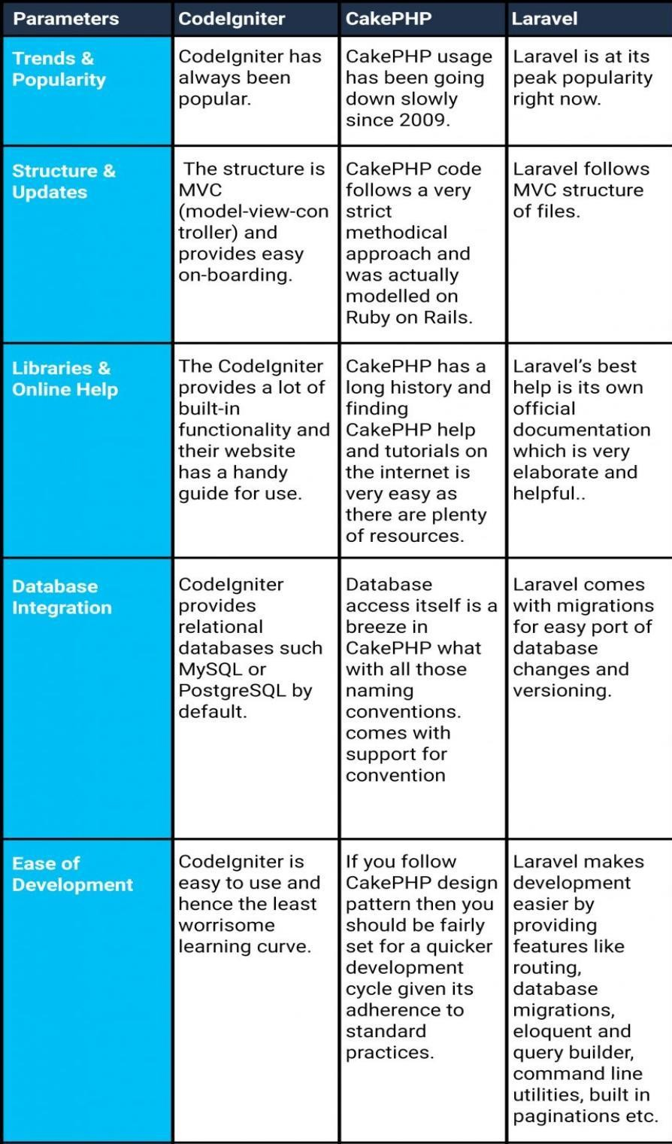

**Figure 2.1** CodeIgniter vs CakePHP vs Laravel (Malhotra,2021)

## Similar System

There are a variety of conversation management systems to choose from. Various systems are available to meet the needs of the users. In this section, chat management systems from various websites are compared to determine the system's many capabilities.

## Instamobile : Chat App Admin Panel

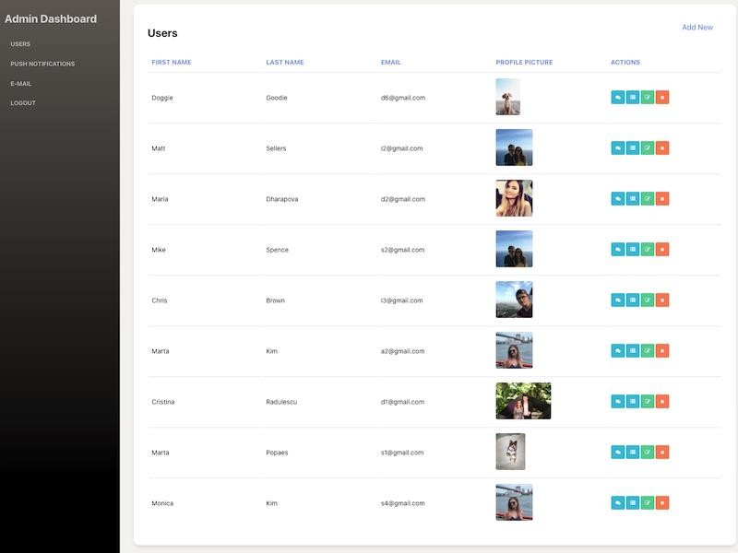

**Figure 2.2** Instamobile – Chat App Admin Panel Interface

Instamobile – Chat App Admin Panel is a chat management system that is developed using React and Node JS. There are several features that are included in this system such as user part where admin can create, delete, edit, and view user. Furthermore, it also has chat feature which allow the admin to have real- time chat with any user. Other than that, this system also has push notifications feature that can push notifications to all the users. Next, this system also includes email feature where admin can send an email to the user. Finally, this system also includes authentication features such as login, logout, and registers.

## ArrowChat: Admin

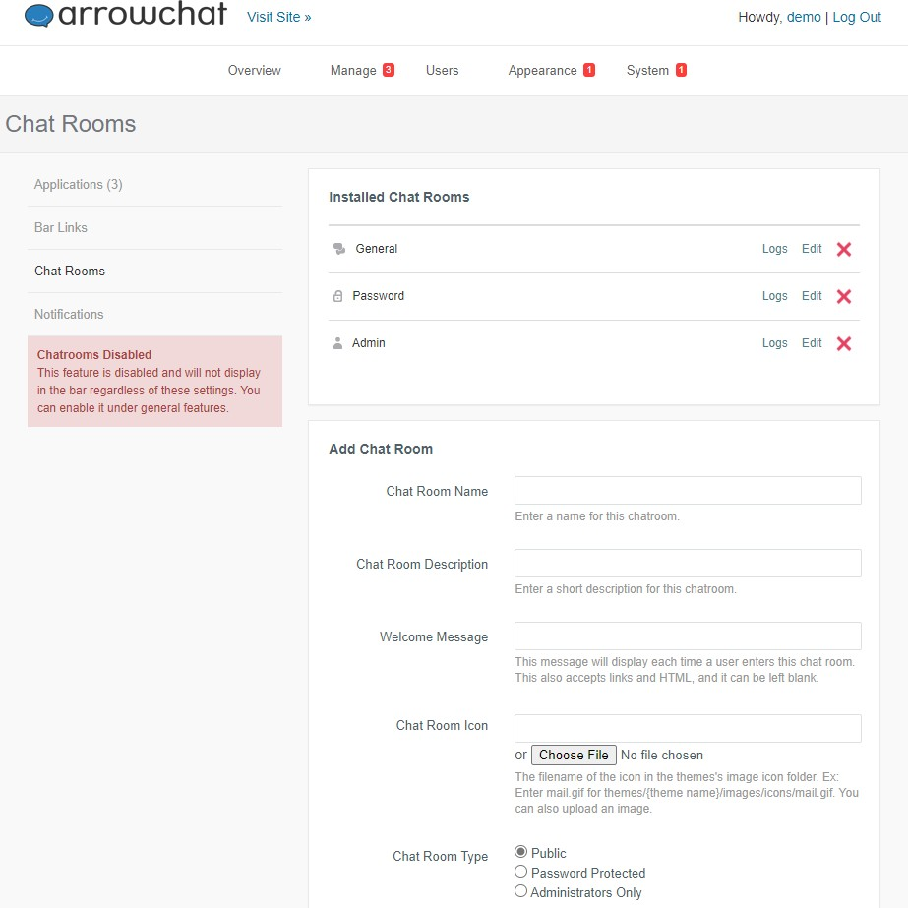

**Figure 2.3** ArrowChat: Admin Interface

Arrowchat: Admin is a Progressive Web Application that is developed to manage the user chat activities. It is develope using PHP and jQuery language. There are some interesting features that be included in this system such as word censoring. This system will automatically block the words that has been set by admin as a forbidden word. Next, it also has chat logs feature where the admin can see the history of user to monitor abuse. This system also has a custom emoji feature. The function of this feature is to upload admin own emoji and it can be use in user chat. Other than that, it also has user bans functions where the user can be ban by username or IP address. This system also has the feature to add new chat rooms for the user.

## Comparison Between Similar Applications

Based on the table 2.1, there are several different features between Instamobile: Chat App Admin Panel(https:/[/www.inst](http://www.instamobile.io/))a[mobile.io/),](http://www.instamobile.io/))

and ArrowChat(https:/[/www.arr](http://www.arrowchat.com/))o[wchat.com/).](http://www.arrowchat.com/)) The first different feature is in term of type of application. ArrowChat : Admin is a Progressive Web Application that has many advantage compare to Instamobile : Chat App Admin Panel. Next, ArrowChat : Admin has the custom emojis feature where the administrator can create a custom emojis to be use by the front end user. For Instamobile : Chat App Admin Panel, it has Live Chat With User feature where ArrowChat : Admin does not have this feature. With this feature, the administrator will be able to have a live chat with the front-end user and will brings many benefits such as customer can directly ask a question from the administrator regarding to the application.

|  |  |  |  |  |  |  |  |  |
| --- | --- | --- | --- | --- | --- | --- | --- | --- |
| System | Progressive Web Application  (PWA) | User Bans | Live Chat with  User | User Report | Reporting On Word Censoring | Custom Emojis | Chat Logs | Push Notifications to User |
| Instamobile: Chat App Admin  Panel | x | x | ➹ | x | x | x | x | ➹ |
| ArrowChat:  Admin | ➹ | ➹ | x | x | x | ➹ | ➹ | x |

**Table 2.1** Comparison of Similar System

## Summary

To summarize, this literature is divided into six sections, the first of which discusses about social community. It explains about the definition of social community, type of online community and example of online community. The second section focuses on the chat management that will be the focus in developing the Virtual Buddy Apps: Chat Management System. The focus then shifts to Progressive Web Application, which will be employed in the system. The following section will solely explain the web framework that later will be use in the Virtual Buddy system. After that, the section of similar system is explained

### CHAPTER 3 RESEARCH METHODOLOGY

The goal of this chapter is to talk about how to do research. The methodology is concerned with the project's process and flow. To conduct the research utilising the waterfall approach, this project follows the Software Development Lifecycle (SDLC). Identification, design, development, prototyping, testing, deployment, and maintenance are the five phases of the waterfall model.

## Research Framework

The waterfall model was employed as the project's fundamental basis. This paradigm is appropriate for the creation of mobile applications. Each waterfall phase is defined and described in detail. Figure 3.1 depicts the waterfall model.

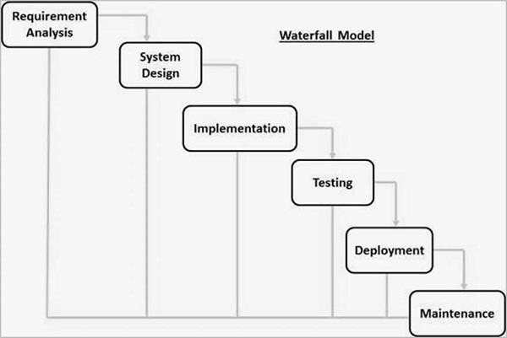

**Figure 3.1** Waterfall Model

The waterfall model contains six phases, as shown in Figure 3.1. The first is the system's requirements analysis where a list of possible needs will be gathered and then will be documented in a specific document. Second phases of waterfall

model are system design which will cover the design of the application architecture. The component and functional testing will be implemented in the implementation phase. The testing phase is for integrating the generated unit into the system, where the system will test for failures or defects. When the application is ready to be deployed. The final step is the maintenance phase, during which the system is improved.

## Phase 1 Requirement Analysis

The requirement analysis phase is the first and most important step of the software development lifecycle, where it gathers data to design a proper system. Some material connected to the project has been found through internet journals and publications to identify the needs needed in this project. The goal of this project is to develop a chat management system that will control the user chat activity. This project uses Progressive Web Application approach that has many advantages in a system development. The analysis is carried out by contrasting existing system related to chat management.

## Phase 2 System Design

The design phase is the second phase of the waterfall model, and it describes how the system is designed. 3.3.1 displays the system's flow chart. Next, 3.3.2 will show the entity relationship diagram (ERD). It is followed by the use case diagram in 3.3.3. Lastly, in 3.3.4 the system design will be covered which depicts the system overview.

## Flowchart

A flowchart is used to better comprehend the system's processes. The system flowchart is shown in Figure 3.1 and Figure 3.2.

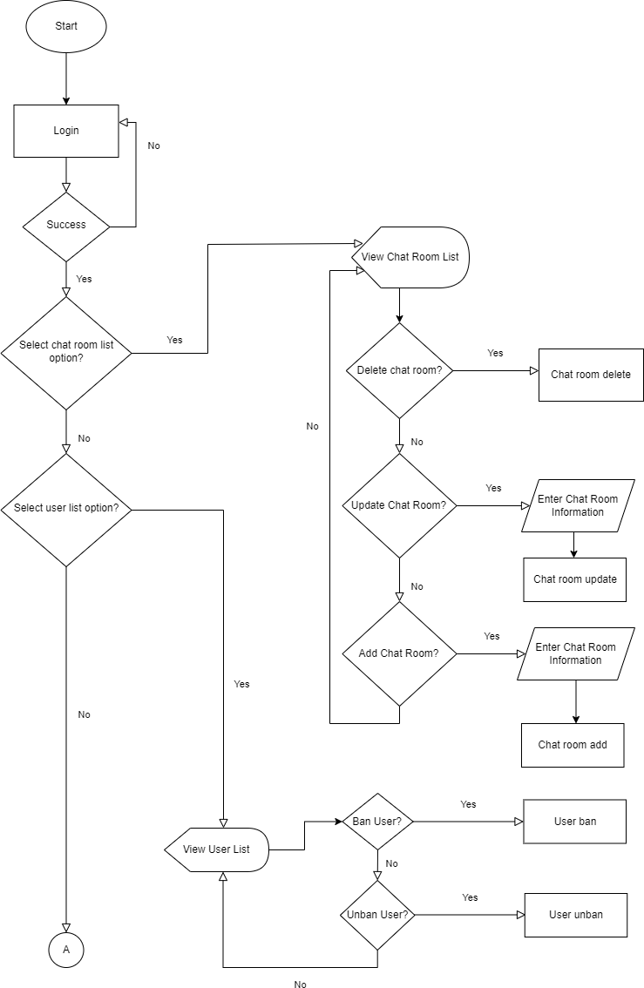

**Figure 3.2** System flowchart

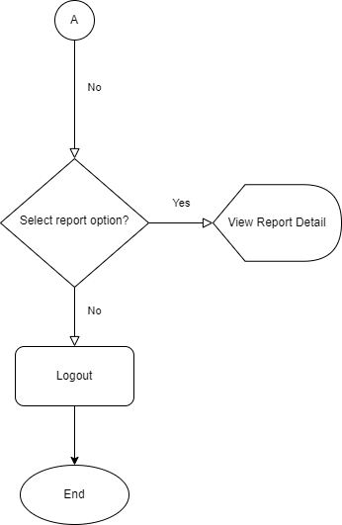

**Figure 3.3** System flowchart

First, the administrator needs to login into the system. If the login is not success, the administrator needs to login again and if the login is successful, the administrator has three choices to make that is chat room list option, user list option and report option. If the administrator selects chat room list option, the list of chat room will be display. Then, the administrator has three choices to be make that is update the chat room, delete the chat room, and add a new chat room. If the administrator selects to delete the chat room, all the information about the chat room will be deleted. If the administrator selects to update the chat room, the administrator needs to enter the chat room information and the chat room information will be updated. If add chat room option is being selected by the administrator, he or she needs to enter the chat room information a new chat room will be added to the system. But, if the administrator did not choose the chat room list option, he or she must select the other two option that is user list option and report option. If user list option selected, the system will display the list of the front- end user and then the administrator needs to choose either to ban or unban the user. The user will be banned if the administrator chooses to ban the user and vice versa if the administrator chooses to unban the user. The third option that can be made by the administrator is report option. The report detail will be display if the

administrator chooses this option, and if there is no option that be made by the administrator, he or she can log out from the system.

## Entity Relationship Diagram

The structural diagram, often known as the entity relationship diagram (ERD), is used in databases. It will show the structure and assist in database design in an ERD. Figure 3.4 depicts the database for this proposed system, as well as the relationships between the components.

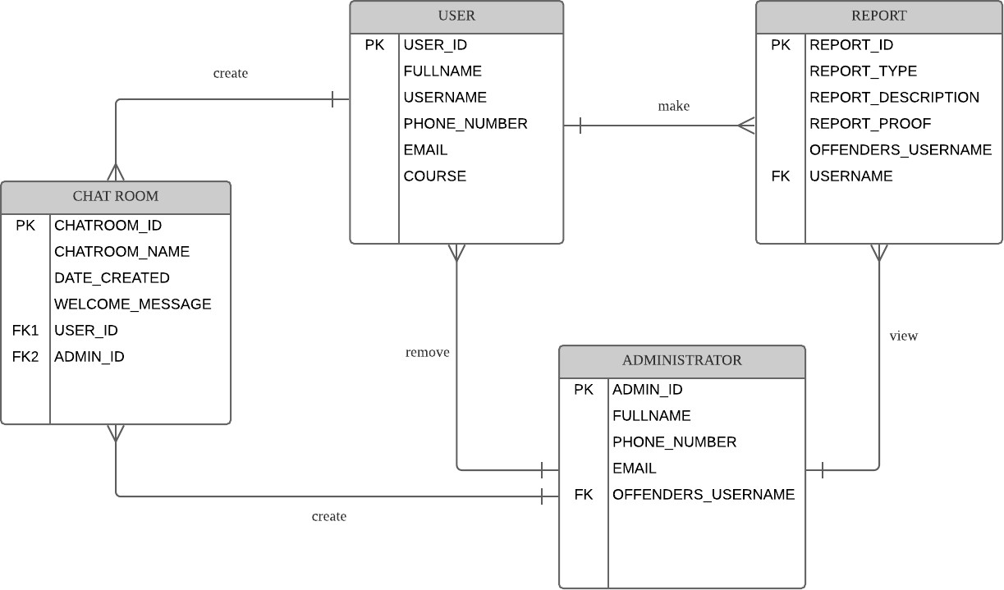

**Figure 3.4** Entity Relationship Diagram (ERD)

Figure 3.2 shows the entity relationship diagram for the project that contains four entity table that is user, chat room, administrator and report that is tied to each other in the system. A user can make many reports about the abuse use of the front-end system and a user can create many chat rooms. An administrator can view many reports from the user and administrator can remove many users who are the offenders to the misuse of the application base on the offender’s username. An administrator also can create many chat rooms.

## Use Case Diagram

Based on figure 3.3, there are five functions in the use case diagram. The administrator can block user, unblock the user, add a new chat room, delete the chat room, and view the report.

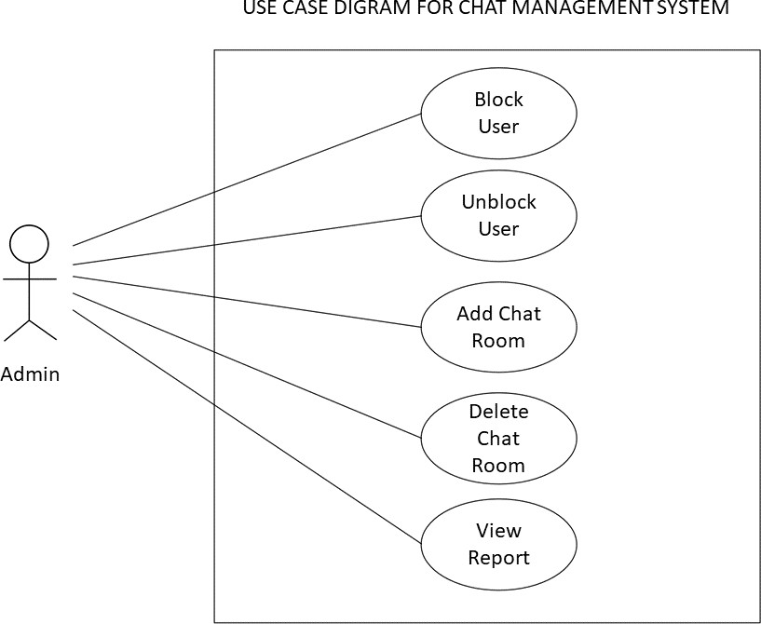

**Figure 3.5** Use Case Diagram

**Table 3.1** Use Case Description of Block User

|  |  |
| --- | --- |
| Use Case ID | UC 001 |
| Use Case | Block User |
| Purpose | To block a user who violate the rules |
| Actor | Admin |
| Trigger | Admin complete selection of the features |
| Precondition | Complete select all the features |
| Main Flow | 1. Admin select feature needed. 2. Admin select user and block the user. |

**Table 3.2** Use Case Description of Unblock User

|  |  |
| --- | --- |
| Use Case ID | UC 002 |
| Use Case | Unblock User |
| Purpose | To unblock a user |

|  |  |
| --- | --- |
| Actor | Admin |
| Trigger | Admin complete selection of the features |
| Precondition | Complete select all the features |
| Main Flow | 1. Admin select feature needed. 2. Admin select user and unblock the user. |

**Table 3.3** Use Case Description of Add Chat Room

|  |  |
| --- | --- |
| Use Case ID | UC 003 |
| Use Case | Add Chat Room |
| Purpose | To add a new chat room |
| Actor | Admin |
| Trigger | Admin click on features |
| Precondition | Admin need to enter all the data to be able to proceed |
| Main Flow | 1. Admin select feature needed. 2. Admin fill in all the information needed. 3. Admin click on the add button to add the new chat room. |

**Table 3.4** Use Case Description of Delete Chat Room

|  |  |
| --- | --- |
| Use Case ID | UC 004 |
| Use Case | Delete Chat Room |
| Purpose | To delete the chat room |
| Actor | Admin |
| Trigger | Admin click on features |
| Precondition | Complete select all the features |
| Main Flow | 1. Admin select feature needed. 2. Admin select the chat room and delete the chat room. |

**Table 3.5** Use Case Description of View Report

|  |  |
| --- | --- |
| Use Case ID | UC 005 |
| Use Case | View Report |
| Purpose | To view the report |
| Actor | Admin |
| Trigger | Admin click on features |
| Precondition | Complete select all the features |
| Main Flow | 1. Admin select feature needed. |

|  |  |
| --- | --- |
|  | 2. System will display the report. |

## User Interface Design

Figure 3.6 show the login page. The administrator needs to insert administrator ID and the password to login to the system.

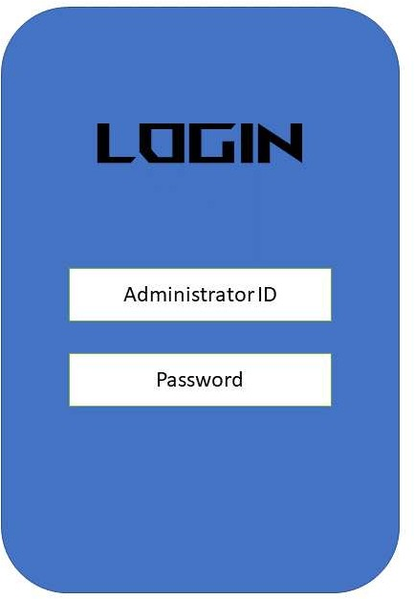

**Figure 3.6** Login Page

Figure 3.7 and Figure 3.8 shows the chat room list interface where administrator can see the list of chat room that available in the system. Information of the chat room such as chat room name, chat room description, date of the chat room being created will be display here. Administrator will have two action to take either to update the chat room information or delete the chat room permanently. There is also search function to help the administrator to easily find the needed information. Figure 3.9 shows the menu bar option in the mobile view.

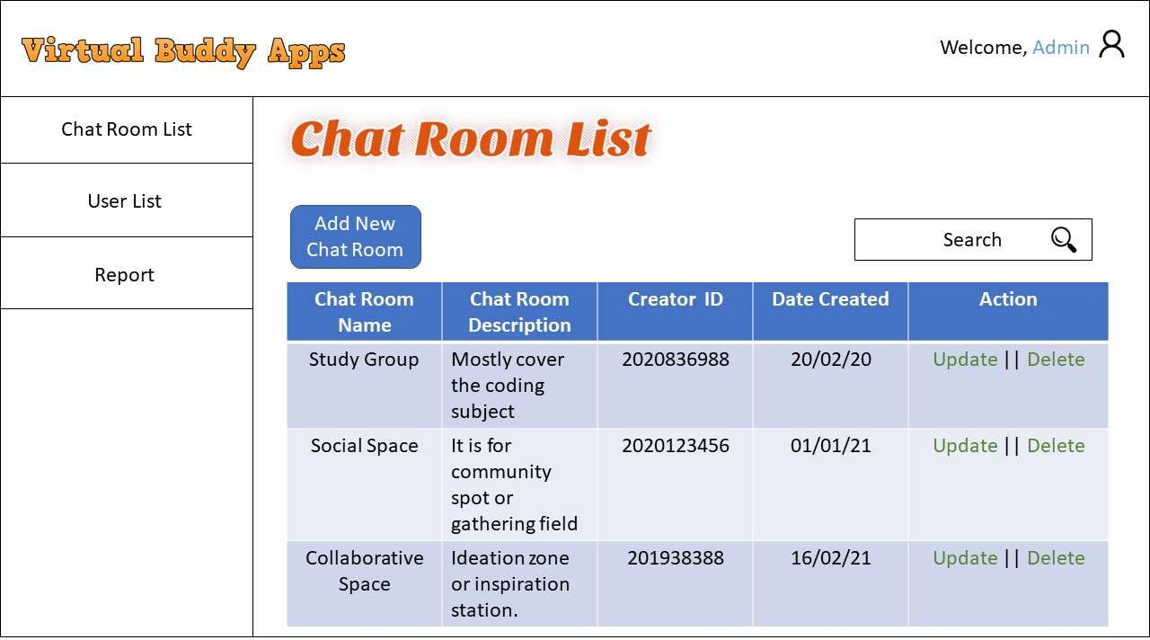

**Figure 3.7** Chat Room List Web View Design

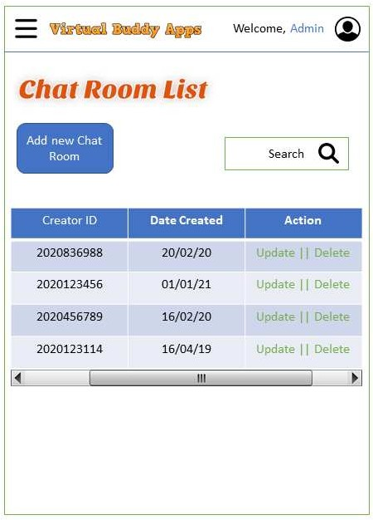

**Figure 3.8** Chat Room List Mobile View Design

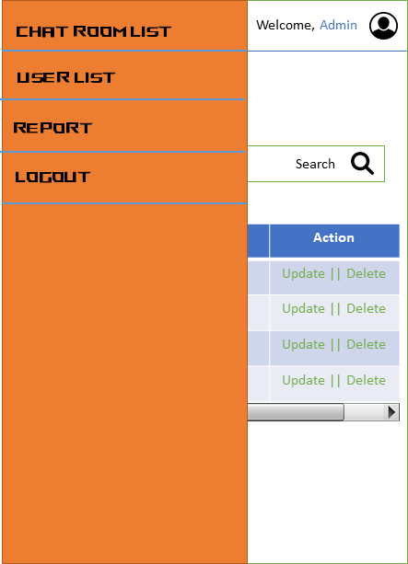

**Figure 3.9** Menu bar option in mobile view

Figure 3.10 and Figure 3.11 shows the add new chat room interface where administrator will fill in all the information needed such as chat room name, chat room description, welcome message, and chat room icon. The administrator then will click the add button to add the new chat room into the system.

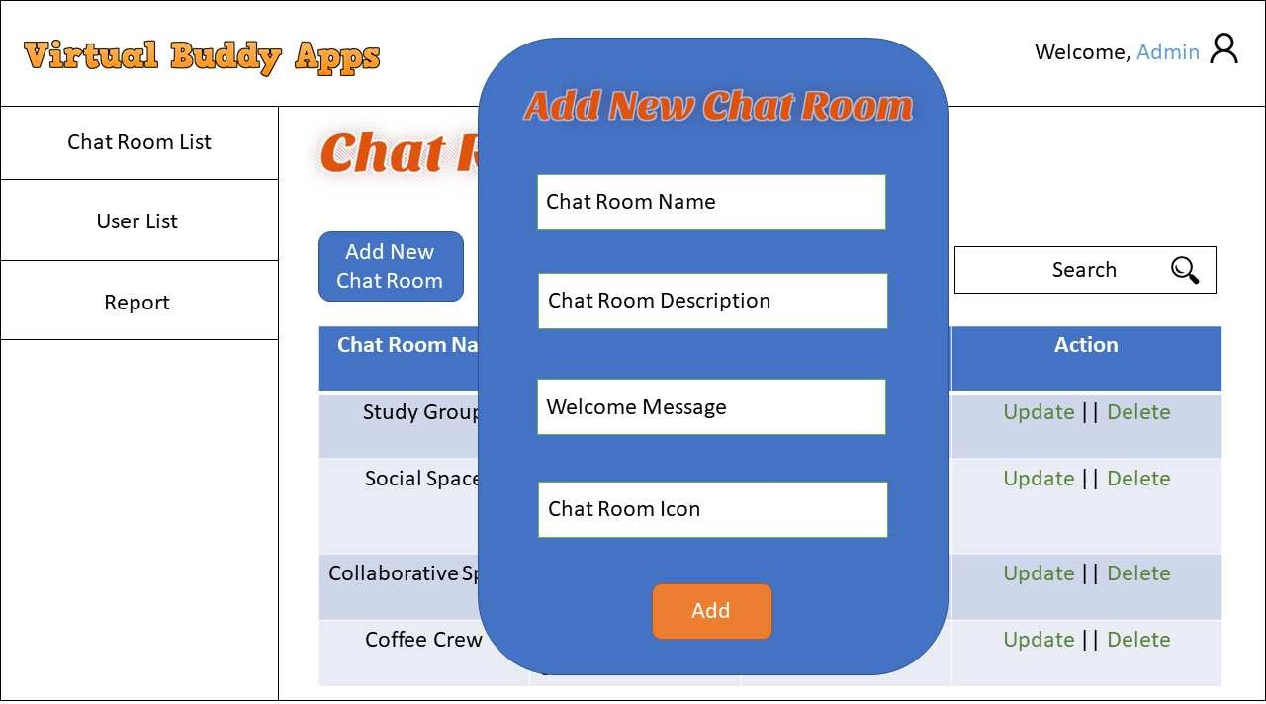

**Figure 3.10** Add New Chat Room Interface in Web View

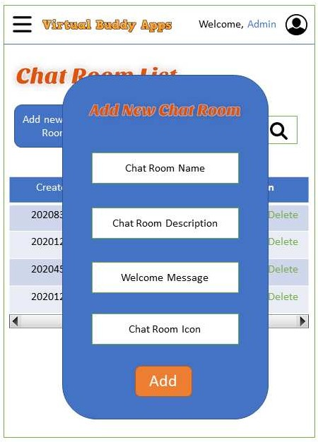

**Figure 3.11** Add New Chat Room Interface in Mobile View

Figure 3.12 and Figure 3.13 shows the user list interface where the information of front-end user such as full name, username and their course will be displayed here. The administrator has two action that can be taken that is block and unblock the user and delete the user permanently.

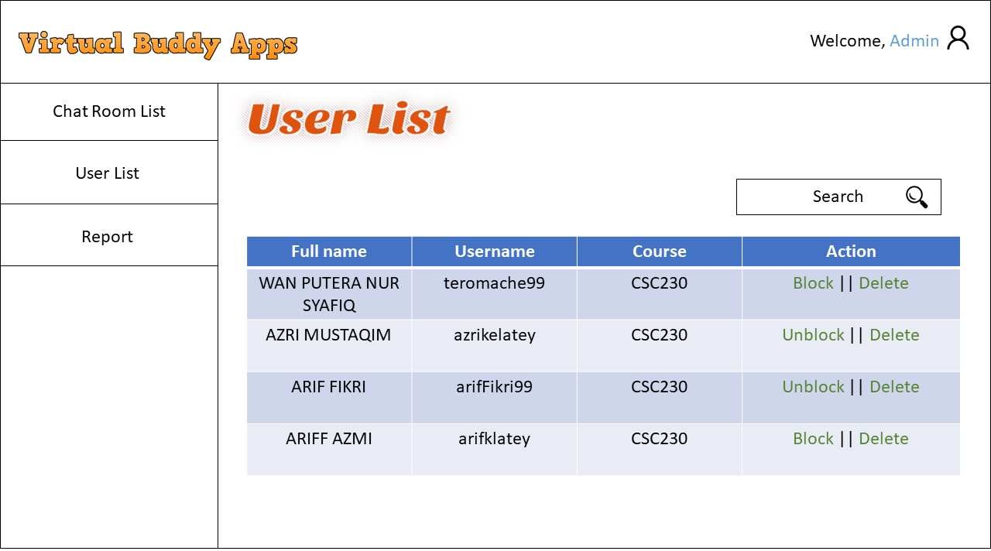

**Figure 3.12** User List Interface in Web View

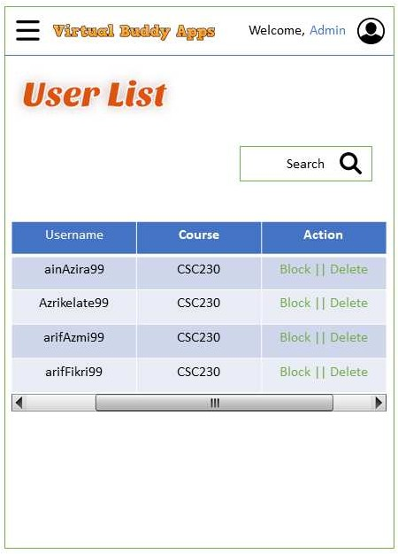

**Figure 3.13** User List Interface in Mobile View

Figure 3.14 and Figure 3.15 shows the report interface where the administrator can see the report that has been made by the front-end user. Information such as reporter username, offender’s username, report type, report description and report proof will be displayed here.

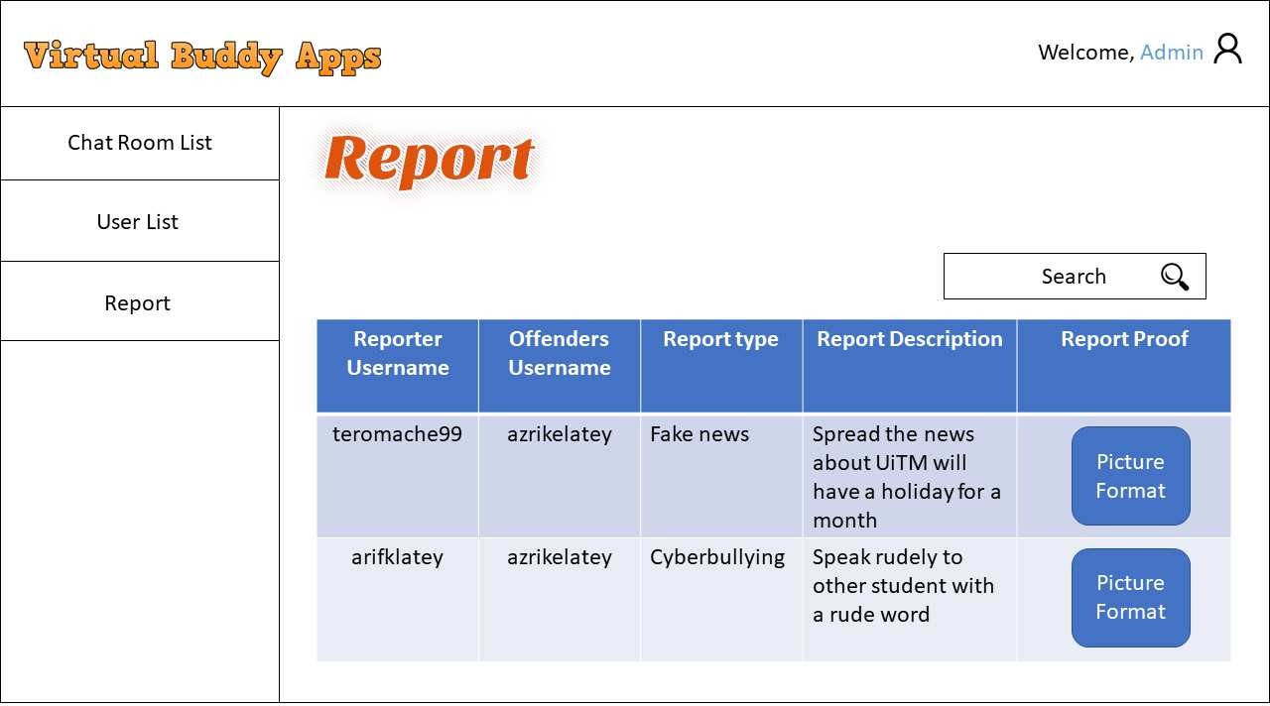

**Figure 3.14** Report Interface in Web View



**Figure 3.15** Report Interface in Mobile View

## Phase 3 Implementation

The technique, related tools, and software that will be employed in the proposed system are described in this section. The system is a Progressive Web Application where both PC and mobile user can use it. The software that will be used to construct the proposed system is shown in Tables 3.1 and 3.2.

|  |  |
| --- | --- |
| **HARDWARE** | |
| **Specification** | **Description** |
| OS name | Microsoft Windows 11 |
| OS manufacture | Microsoft Corporation |
| System type | x64-based pc |
| Physical ram | 16gb |
| Device memory | 1tb SSD and 1tb HDD |
| Device processor | Intel Core i7 10th Gen |
| Device graphic processor | Nvidia RTX2060 |

**Table 3.1**: Specification of device used.

The device specification that will be used to construct this project is shown in Table 3.1. Microsoft Windows 11 is the operating system on the device, while

Microsoft Corporation is the manufacturer of the operating system. It has an 16GB random access memory (RAM) a 1tb SSD and 1tb HDD for read-only memory (ROM). Next, this device's processor is Intel Core i7 10th Gen. Finally, this device use Nvidia RTX 2060 for the graphic processor.

|  |
| --- |
| **Software** |
| Visual Studio |
| XAMPP |
| Google Chrome |

**Table 3.2**: Software Requirement.

The software that will be used to develop the system is shown in Table 3.2. The first piece of software is Visual Studio, which is used to write the code for the system. The proposed system data will then be stored in a database created with XAMPP. Then there's Google Chrome, where the preview of the system will be display here.

## Phase 4 Testing

The prototyping phase is the next step. After the system has been completed, this phase will be completed. It is necessary to ensure that the system is free of errors. Each component of the system will be thoroughly examined to ensure that it functions properly.

## Test Case

|  |  |  |
| --- | --- | --- |
| Event | Expected Outcome | Result |
| To test the functionality  of user profile button. | It will be selected as  one of its features. | Pass/Fail |
| To test the functionality  of chat room navigation bar button. | It will display the content of chat room | Pass/Fail |

|  |  |  |
| --- | --- | --- |
|  | such as chat room  name. |  |
| To test the functionality  of update button in chat room content. | It will update the  information of the chat room. | Pass/Fail |
| To test the functionality of delete button in chat  room content. | It will delete the information of the chat  room. | Pass/Fail |
| To test the functionality of add new chat room button in chat room  content. | The chat room information form will be pop-up. | Pass/Fail |
| The system user fills the input needed in the add chat room form. | The new chat room will be added to the database and will be display in the chat  room content. | Pass/Fail |
| To test the functionality  of user list navigation bar button. | It will display the  content of user list such as username. | Pass/Fail |
| To test the functionality of block user button in  the user list content. | The selected user will be block. | Pass/Fail |
| To test the functionality  of unblock user button in the user list content. | The selected user will be unblocked. | Pass/Fail |
| To test the functionality  of report navigation bar button. | It will display the  content of report such as reporter username. | Pass/Fail |
| To test the search function. | The search content will be display based on  input keyword. | Pass/Fail |

**Table 3.3**: Test case for the button of the input data and output data interface.

## Phase 5 Deployment

Deployment occurs at the conclusion of the development process. Once testing is completed, the application is ready for deployment. The programme is available in the appropriate app store for end-user use.

## Phase 6 Maintenance

This is the project's last phase, during which it will do system maintenance when faults or bugs are identified. This phase will begin only after the system has been completed. This is also the phase when any system updates or improvements will be introduced.

## Summary

To summarise, the ideal technique to design a mobile application is to use the waterfall model of the Software Development Life Cycle (SDLC). Requirement analysis, system design, implementation, testing, deployment, and maintenance are the six phases of the waterfall model. The previous section provided detailed information on each phase.

## REFERENCES

A. Biorn-Hansen, T. A. Majchrzak, and T.-M. Gronli (2018). Progressive Web Apps For the Unified Development of Mobile Applications in *Web Information Systems and Technologiesm*, 64-86’.

Andreas Biørn-Hanse, Christoph Rieger, Tor-Morten Grønli, Tim A. Majchrzak & Gheorghita Ghinea (2020). An Empirical Investigation of Performance Overhead in Cross-Platform Mobile Development Frameworks. *Empirical Software Engineering.* 25 : 2997-3040. https://doi.org/10.1007/s10664-020-

09827-6

Annita Ashutoshbhai Mangukiya (2020). Laravel: A Framework for Building PHP Apps. <http://dx.doi.org/10.13140/RG.2.2.25131.26402>

Arum Nisma Wulanjani (2018). DISCORD APPLICATION Turning a Voice Chat Application for Gamers into a Virtual Listening Class. *2nd English Language and Literature International Conference (ELLiC) Proceedings.*2.

A.Subari, S Manan & E Ariyanto (2020). Design of E-Office System in Vocational School Diponegoro University Using Code Igniter Framework. *IOP Conference Series: Materials Science and Engineering,*801(1)*.* doi:10.1088/1757-899X/801/1/012141

Azwa Rahman (2020). *“UiTM Nafi Akan Ambil Tindakan Terhadap Pelajar Yang Menyertai Petisyen Perletakan Jawatan Vivy Yusoff”.* https://gempak.com/berita-terkini/uitm-nafi-akan-ambil-tindakan-terhadap- pelajar-yang-menyertai-petisyen-perletakan-jawatan-vivy-yusof-34425

C J Gómez-Sierra (2021). Design and Development of a PWA - Progressive Web Application, to Consult the Diary and Programming of a Technological Event. *IOP Conference Series: Materials Science and Engineering*, 1154(1)*.* doi:10.1088/1757-899X/1154/1/012047

Detik.com (2017). *“Awas Hoax! Kabar Tipuan yang Mematikan”.* https://inet.detik.com/cyberlife/d-3122471/awas-hoax-kabar-tipuan- yangmematikan.

Divyam Goyal, Pulkit Jain & Bharat Bhushan (2020). Enhancement of Security using Various Web Development Frameworks. *Proceedings of the International Conference on Innovative Computing & Communications (ICICC).* https://dx.doi.org/10.2139/ssrn.3600740

Erika Heidi (2020). How to Use Migrations to Create and Manage Database Tables in Laravel. https:/[/www.digitaloc](http://www.digitalocean.com/community/tutorials/how-to-use-)e[an.com/community/tutorials/how-to-use-](http://www.digitalocean.com/community/tutorials/how-to-use-) migrations-to-create-and-manage-database-tables-in-laravel

Franny Harold (2021). *“4 Examples of Great Online Communities and What Makes Them Work.”* https://khoros.com/blog/great-online-communities

Gumgum Gumelar, Zarina Akbar & Erik (2018). Engagement and the Spread of Fake News. *Advances in Social Science, Education and Humanities Research. 165.*

Hang Zhang, Xiaohua Sun, Liang Chen, Hongze Yang & Yandong Wang. The Meditation Role of Moral Personality Between Childhood Psychological Abuse and Cyberbullying Perpetration Attitudes of College Students (2020). *Frontiers in Psychology.* 11 : 1215. doi: 10.3389/fpsyg.2020.01215

Hannah Gaffney, Dorothy L Espelage, David P.Farrington & Maria M. Ttofi. (2018). Are cyberbullying intervention and prevention programs effective? A systematic and meta-analytical review. *Aggression and Violent Behaviour. 45.* doi: 10.1016/j.avb.2018.07.002

Jeel Patel (2021). “*Top 8 Backend Frameworks to Use in Web App Development.”*

https:/[/www.monocubed.com/best](http://www.monocubed.com/best-backend-frameworks/)-[backend-frameworks/](http://www.monocubed.com/best-backend-frameworks/)

Jennifer L. Betts (2019). “*Create a Virtual Friend.”*

https://teens.lovetoknow.com/Create_a_Virtual_Friend

John, A., Glendenning, A. C., Marchant, A., Montgomery, P., and Hawton, K. (2018). Self-harm, suicidal behaviours, and cyberbullying in children and young people: systematic review. J. Med. Int. Res. 20, e129.

John Prabhu (2019). *“MVC Architecture & Its Benefits in Web Application Development.”* https:/[/www.simform.com/blog/l](http://www.simform.com/blog/laravel-vs-codeigniter/)a[ravel-vs-codeigniter/](http://www.simform.com/blog/laravel-vs-codeigniter/)

Kompas.com (2017, Aug 20). *“Panasnya Media Sosial Gara-gara Berita Hoax”.* <http://ekonomi.kompas.com/read/2017/01/24/06060001/panasnya.media.s> osial.gara-gara.berita.hoax.?page=all.

ladychampionz (2020).*” Active Chat Monitoring and Suspicious Chat Detection over Internet”.* https://projectchampionz.com.ng/2020/04/18/active-chat- monitoring-and-suspicious-chat-detection-over-internet/

Liz (2020). *“What is a Social Community?”* https://www.successful- blog.com/1/what-is-a-social-community/

Mantra Malhotra (2021). “*CodeIgniter vs CakePHP vs Yii vs Laravel : Which Framework* *Would You Choose in 2021?.”* https:/[/www.valuecoders.](http://www.valuecoders.com/blog/technology-and-apps/codeigniter-vs-)c[om/blog/technology-and-apps/codeigniter-vs-](http://www.valuecoders.com/blog/technology-and-apps/codeigniter-vs-) cakephp-vs-yii-vs-laravel/

Michael Longley & Yasmine N. Elglaly (2021). Accessibility Support in Web Frameworks. In *The 23rd International ACM SIGACCESS Conference on Computers and Accessibility (ASSETS ’21)*. https://doi.org/10.1145/3441852.3476531

Mole, Patrick V. (2020). Progressive Web Apps: A Novel Way for Cross-Platform Development.

Nazar Kvartalnyi (2021). *“Benefits of Progressive Web Apps (PWA) – Advantages and Disadvantages.”* https://inoxoft.com/blog/benefits-of-progressive-web- apps-pwa-advantages-and-disadvantages/

Oluwatofunmi Adetunji, Chigozirim Ajaegbu, Nzechukwu Otuneme & Olawale J. Omotosho (2020). Dawning of Progressive Web Application (PWA): Edging Out the Pitfalls of Traditional Mobile Development. *American Scientific Research Journal for Engineering, Technology, and Sciences (ASRJETS),*68(1),85-99.

Parbat Thakur (2018). Evaluation and Implementation of Progressive Web Application.

Parkavi A, Sowmya B J & Pushpalatha M N (2020). “FRIENDLY CHAT” – A chat application with multi-headed classification models for identifying abusive

levels and their comparative study. *Journal of Physics: Conference Series.*

1706. doi:10.1088/1742-6596/1706/1/012145

Raveena Nagotra (2021). *”Pensyarah UiTM Didakwa Buat Gangguan Seksual”.*

*htt*[*ps://w*](http://www.malaysiakini.com/news/579466)*ww*[*.malaysiakini*](http://www.malaysiakini.com/news/579466)*.c*[*om/ne*](http://www.malaysiakini.com/news/579466)*w*[*s/579466*](http://www.malaysiakini.com/news/579466)

TribunnewsBogor.com (2017, Aug 20). *“Begini Cara Mendeteksi Berita Hoax, Kalimat ‘Dari Grup Sebelah Patut Dicurigai”.* <http://bogor.tribunnews.com/2016/11/09/begini-cara-mendeteksi-> beritahoax-kalimat-dari-grup-sebelah-patut-dicurigai?page=all.

Yakob Utama Chandra, Surjandy & Ernawaty (2017). Higher Education Student Behaviours in Spreading Fake News on Social Media: A Case of LINE Group. *International Conference on Information Management and Technology.*54-59.

Yuan, L. Y., Chen, L. L., and Pan, L. Y. (2017). Current situation of cyberbullying and its effect on suicidal ideation in Nanning university students.

*Chinese J. Sch. Health*. 38, 945–947. doi: 10.16835/j.cnki.1000-9817. 2017.06.048

Yusuf Kurnia & Refin (2020). Ayam Gepuk Pak Gembus Web-Based Ordering Application Design with Codeigniter Framework. *Bit-Tech*,2(2),65.

Zsila, Á, Róbert, U., Griffiths, M. D., and Demetrovics, Z. (2019). Gender differences in the association between cyberbullying victimization and perpetration: the role of anger rumination and traditional bullying experiences. Int. J. Mental Health Addict. 17, 1252–1267. doi: 10.1007/s11469-018-9893-9

Zych, I., Baldry, A. C., Farrington, D. P., & Llorent, V. J. (2018). Are children involved in cyberbullying low on empathy? a systematic review and meta-analysis of research on empathy versus different cyberbullying roles. Aggress. Violent Behav. 45, 83–97.

Zych, I., Baldry, A. C., Farrington, D. P., and Llorent, V.J. (2018). Are Children Involved in Cyberbullying Low on Empathy? A Systematic Review and Meta-Analysis of research on Empathy Versus Different Cyberbullying Roles. *Aggress. Violent Behav.* 45, 83-97. doi: 10.1016/j.avb.2018.03.004

**APPENDICES**

## APPENDIX 1

### Gantt Chart

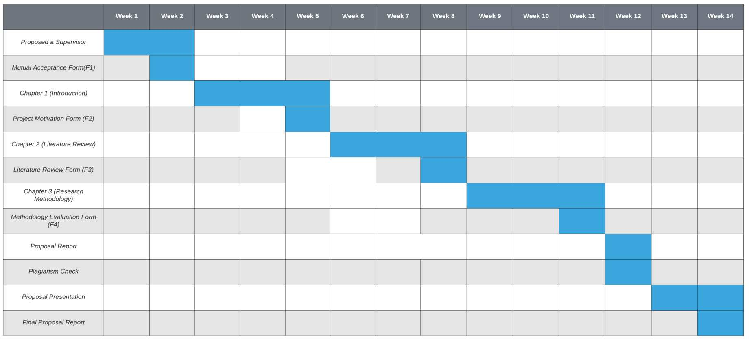

1